Pupil premium strategy statement – Layton Primary School
Before completing this template, read the Education Endowment Foundation’s guide to the pupil premium and DfE’s pupil premium guidance for school leaders, which includes the ‘menu of approaches’. It is for school leaders to decide what activity to spend their pupil premium on, within the framework set out by the menu.
All schools that receive pupil premium are required to use this template to complete and publish a pupil premium statement on their school website by 31 December every academic year.
If you are starting a new pupil premium strategy plan, use this blank template. If you are continuing a strategy plan from last academic year, you may prefer to edit your existing statement, if that version was published using the template.

Before publishing your completed statement, delete the instructions (text in italics) in this template, and this text box.

This statement details our school’s use of pupil premium funding to help improve the attainment of our disadvantaged pupils.
It outlines our pupil premium strategy, how we intend to spend the funding in this academic year and the outcomes for disadvantaged pupils last academic year.

School overview
Detail | Data
Number of pupils in school | 618
Proportion (%) of pupil premium eligible pupils | 41.52%
Academic year/years that our current pupil premium strategy plan covers (3-year plans are recommended – you must still publish an updated statement each academic year) | 2025 to 26  2026 to 27  2027 to 28
Date this statement was published | 15.12.25
Date on which it will be reviewed | 30.7.26
Statement authorised by | Mr J Clucas,  Headteacher
Pupil premium lead | Mrs C Scott,  Deputy Headteacher
Governor / Trustee lead | Vice-Chair Governor,  Mr S Shaw

Funding overview
Detail | Amount
Pupil premium funding allocation this academic year | £390,570
Pupil premium funding carried forward from previous years (enter £0 if not applicable) | £ 0
Total budget for this academic year  If your school is an academy in a trust that pools this funding, state the amount available to your school this academic year | £390,570

Part A: Pupil premium strategy plan

Statement of intent
At Layton Primary School, we believe that all our pupils have the right to access high quality inclusive teaching of an ambitious critical thinking curriculum irrespective of their background or challenges that they face. It is our intention that our disadvantaged pupils make the best progress, irrespective of their ability. High attainers, in receipt of pupil premium, are expected to make the same progress as the lower attainers. The intention of this strategy is to support all our pupils to become resilient independent learners regardless of whether they're disadvantaged or not.

The school’s thinking is directly influenced by the work of Dylan Wiliam, John Hattie, Robin Alexander and Guy Claxton in its vision to achieve the best outcomes for all groups of pupils. All of these philosophies, and evidence-based approaches, demonstrate those things that make the biggest difference in classrooms for all pupils. All of these approaches prioritise formative assessment, desirable difficulty, the power of improving through classroom talk and the mindset required of all, pupils and teachers, to improve.

At the heart of this strategy is a relentless focus on ensuring that all pupils have access to quality first teaching. This is proven to have the greatest impact on closing the disadvantage attainment gap and at the same time will benefit all pupils in school. Effective teaching and learning strategies are essential, and have a vital impact, in raising standards for all groups of pupils including those in receipt of pupil premium funding. We implement and utilise these aspects of teaching and learning from EYFS to year 6. The key principles of our strategic plan includes:
1. Embedding the five principles of inclusive practice: This includes embracing the cognitive similarities, adopting high quality instruction techniques, ensuring lessons are accessible by default, adapting minimally and appropriately for all pupils, empowering effective formative and summative assessment of pupils to inform future teaching and learning.
2. Prioritising formative assessment strategies: Knowing where pupils are in their learning is essential if we are to move them forward. Professional development for all staff is centred around development of formative assessment in order to shape the curriculum. Effective CPD in this area for all staff supports pupil learning.
3. Implementing ambitious curriculum design: Our curriculum is ambitious for all pupils. Designing, implementing and assessing the impact of the curriculum takes time and skill and development over time of both staff and pupils. Our staff lead their subject across school and ensure that the curriculum reflects formative assessment strategies and that the curriculum is delivered with ambitious intentions.
4. Quality first teaching; the vast majority of our learning takes place inside the classroom; however, interventions are necessary and are delivered by skilled individuals utilising formative and summative assessments. These may be speech and language trained support assistants, academic learning counsellor, learning mentors or experienced learning support assistants. Interventions strategies are utilised in order to ensure children are able to access our ambitious curriculum
5. Developing questioning strategies for all groups of pupils. Key questioning around multi- objective lessons leads to pupils accessing, developing and building on learning. Our curriculums are centred around children developing critical thinking skills through dialogic teaching strategies.
6. A curriculum planned for spaced learning. Pupils encounter topics and associated objectives frequently and often and are provided with tasks which ensure they apply those skills on a regular basis. Lessons are designed to build on existing learning and develop opportunities to apply existing knowledge, develop new skills and apply them in a wide variety of situations. This curriculum results in rapid gains for all groups of pupils, including those in receipt of the pupil premium. Regular retrieval practice ensures children know and remember more over time.

Challenges
This details the key challenges to achievement that we have identified among our disadvantaged pupils.
Challenge number | Detail of challenge
1 | A low baseline on entry to Foundation Stage  EYFS GLD outcomes are below the national average from their significantly below starting point. In 2025, assessment data indicates that our reception pupils were lower than National across all ELGs, with overall GLD 16% below National for all pupils and 11% below for disadvantaged pupils against disadvantaged pupils nationally.  Children in the early years start school with an extremely low baseline in communication and language; approximately 30% of all pupils are at age related expectations. This aligns with the outcome of the Early Years Validated Data and low outcomes in speaking. An inclusive, intensive approach to early intervention is prioritised from the day the children start in Foundation in order that school works to develop pupils’ communication and language skills from the moment they start school. As a result, they make substantial gains in their communication and language.
2 | Low outcomes at the end of Key Stage One  Standardised assessment data at the end of KS2 indicates sustained above average attainment and achievement for Reading, Writing, Maths combined (2023- 66.7% 2024- 68.9% 2025-65.2%).  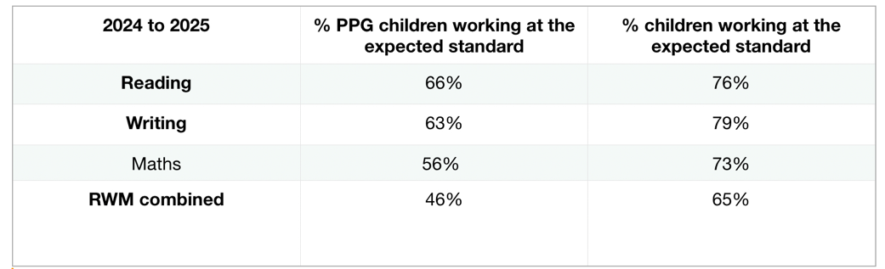  The data for 2025:  In 2025, 29% of PPG pupils achieved greater depth in reading, 15% in writing and 32% in Maths; these are above national and significantly above local averages.  Assessments, observations and discussions with pupils suggests some pupil premium eligible pupils have more barriers to learning to overcome than their peers.  On entry to Foundation Stage, for many years, the general trend is that our pupil premium children start the year well below age related expectations compared to their peers. For the current cohort, 35% of our pupil premium children enter at age-related expectations in most areas (8 children out of 23). The school vision is to narrow the gap for these children significantly by the end of KS1 such that they can align with their peers by the end of KS2.
3 | Developing oracy skills throughout school  Assessments, observations, and evidence gained from dialogic teaching in all classrooms indicates underdeveloped oral language skills and vocabulary gaps among a large proportion of pupil premium children.  These are evident throughout school, but the general trend is that the vocabulary gap is more prevalent among our pupil premium children.
4 | Improving attendance  Our attendance data over the last 3 years indicates that attendance among pupil premium children has been between 1.5% and 3% lower than for a non-pupil premium child. The percentage of pupil premium children who are ‘persistently absent’ is also higher with a difference of over 10% in recent years.  Attendance and persistence absentee rates for pupil premium children are as follows:  2022-2023 - 93.74% 19.42% (PA)  2023-2024 - 92.87% 26.11% (PA)  2024-2025 - 93.59% 20.72% (PA)  Attendance and persistence absentee rates for non-pupil premium children are as follows:  2022-2023 - 95.42% 8.97%(PA)  2023-2024 - 94.92% 11.2% (PA)  2024-2025 - 95.57% 8.2% (PA)  To date this academic year, over 50% of our children who are regularly late are PP children. This is a trend for our school and informs decisions of when Phonics is delivered across school.
5 | Social and emotional barriers to learning  Our assessments of trends on data recorded on CPOMS, observations, class teacher referrals and discussions with pupils and families indicates social and emotional barriers to learning for some pupil premium eligible children. These challenges could potentially affect pupil premium children, including their attainment and attendance.  Lunch clubs are provided each day to support with social and emotional needs; to date (in 2025-2026), on average, 41% of the children attending these clubs are pupil premium children.  Individual and group support for children with barriers to their learning, including social and emotional needs is provided following referrals from class teachers, parents and external agencies such as Children’s Social Care. To date (in 2025-2026) 43.75% of those children are pupil premium children and this is likely to increase as last year, this figure was 50.68%.

Intended outcomes
This explains the outcomes we are aiming for by the end of our current strategy plan, and how we will measure whether they have been achieved.
Intended outcome | Success criteria
Improved GLD outcomes for pupil premium children every year for the duration of this strategy. | Percentage of pupil premium children achieving Good Level of Development (GLD) will increase each year from 2026 to 2028. This will be triangulated with other sources of data including liaison with resident Speech and Language staff, observation of dialogic teaching and collaborative approach to planning to focus on increasing the number of children reaching ELG EXP in Communication and Language Early Learning Goal.
Improved end of KS1 and KS2 data for pupil premium pupils achieving expected outcomes in Reading, Writing and Maths combined. | The trends in KS2 data to 2027/28 will indicate a narrowing in the gap in the percentage of children achieving RWM combined and within this, more than 50% pupil-premium pupils achieved Reading, Writing and Maths combined.
Improved oral language, skills and vocabulary for all but particularly among pupil premium children. | Assessments, teaching observations and liaison with school-based speech and language therapists indicate significantly improved oral language among pupil premium children.  This is triangulated with other sources of evidence including children's use of vocabulary in retrieval practice, formative and summative assessment, high quality assessment for learning and dialogic teaching strategies in daily classroom practice.
To achieve and sustain improved attendance for all pupils, notably our pupil premium children. | Sustained attendance, at least in line with national average, by 2027/28 evidenced by:  - Average attendance for all pupils to remain above 95% and the attendance gap between pupil premium children and their peers to be consistently below 2%.  - The percentage of all pupils who are persistently absent being below 14% and the figure among pupil premium children being no more than 12% higher than their peers.
To achieve and sustain improved emotional health for all our pupils in school particularly our pupil premium children. | Sustained high levels of pupil's resilience by 2027/28 evidenced by:  - a reduction in behaviour incidents reported on CPOMS  - an increased number of children attending playtime club offers.  - an extended enrichment programme and Personal Development Offer (reviewed annually).  - a significant increase in extra-curricular activities, particularly among pupil premium pupils.  - pupil voice indicates that children feel happy and safe in school which enables them to thrive and learn.

Activity in this academic year
This details how we intend to spend our pupil premium funding this academic year to address the challenges listed above.

Teaching (for example, CPD, recruitment and retention)
Budgeted cost: £ 203,400
Activity | Evidence that supports this approach | Challenge number(s) addressed
Implement and embed the five principles of inclusive practice throughout school, whilst continuing to embed assessment for learning strategies, supported by high quality Learning Support Assistants. | The five principles of inclusive practice represent a vital, evidence-informed pedagogical shift that aims to make mainstream provision more effective and accessible for the widest possible range of students. Embedding the principles of inclusive practice is aimed to enhance the quality of provision for all and is integral to the culture of Layton Primary School.  The 5 principles of inclusive teaching:  - Embrace cognitive similarity  - Prioritise high-impact core instruction  - Make lessons accessible by default.  - Adapt minimally and appropriately  - Empower effective teacher assessment  https://steplab.co/resources/inclusionpaper/682b7ad7af6f000001b321fd  In addition to this, evidence is collated from:  The Dialogic Teaching Companion - Robin Alexander  Building Learning Power - Guy Claxton  Visible Learning for Teachers - John Hattie | 1, 2, 3
Implementation of  FFT reading fluency assessment  as a diagnostic assessment in reading.  Implement gap analysis based on the above.  CPD for all staff to ensure that the data is used to inform future planning. | The low level of reading fluency of the lowest 30% of readers is likely to indicate a reading difficulty that will impact this group across the curriculum. Monitoring the oral reading fluency of the lowest 30% of readers, in particular, and addressing this deficit as early as possible is our vision. When used effectively, diagnostic assessments can indicate areas for development for individual pupils.  https://ffteducationdatalab.org.uk/2024/11/measuring-reading-fluency-during-primary-education/ | 1, 2, 3
Embedding progressive dialogic teaching strategies across the school curriculum to close the vocabulary gap for all children. | According to EEF, oral language interventions can have a positive impact at all phases of education, but the impact is highest in the early years (+7 months), and higher in primary schools (+6 months) than in secondary (+5 months).  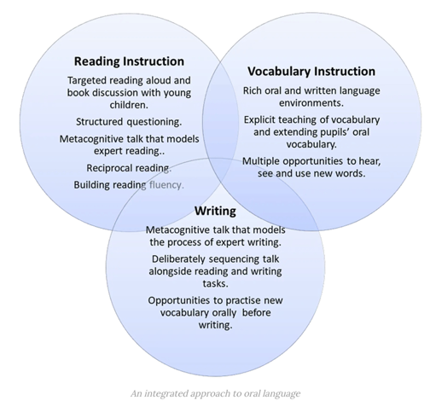  At Layton we believe effective oral language approaches are best integrated into the use of purposeful, curriculum-focused, dialogue and interaction and should be considered as a core element of developing oracy, rather than a distinct subject area in its own right. Oracy is a culture not an intervention.  https://educationendowmentfoundation.org.uk/news/what-does-the-evidence-base-tell-us-about-effective-oral language-practice | 1, 2, 3
CPD for all staff on the importance of adult-pupil interaction to support oral language development, monitored by the Teaching and Curriculum Leader (TLCL). | The Education Policy Institute (EPI) report that by the end of Reception year, children who are experiencing disadvantage, are on average, 4.6 months behind other children in their learning. It is reported that this gap doubles, on average, by the end of primary school and doubles again by the end of secondary school.  https://educationendowmentfoundation.org.uk/early-years/high-quality-interactions | 1, 2, 3
Embed knowledge and understanding of the PSHE curriculum to  improve children’s relationship skills, and emotional wellbeing, of all pupils which will result in building their learning power.  CPD on explicit  instruction of self-regulation will be embedded into routine educational practices. | The PSHE curriculum responds to the changing needs within school and the wider community. This Layton-centric approach equips children with the skills to be a responsible citizen and a life-long learner. This pro-active approach allows staff to resource families, and children, with the tool-kit they require when managing challenging issues and relationships. All staff are provided with reflective sessions half-termly, via the DSL to discuss and explore any challenging issues and how best to support pupils.  Evidence shows that educators can implement approaches that benefit young children's self-regulation and/or executive function. The EEF's Early Years Toolkit finds that self-regulation approaches may also be effective in promoting successful learning. This is relevant to all children throughout school.  https://educationendowmentfoundation.org.uk/early-years/evidence-store/self-regulation-and-executive-function | 5

Targeted academic support (for example, tutoring, one-to-one support, structured interventions)
Budgeted cost: £ 145, 000
Activity | Evidence that supports this approach | Challenge number(s) addressed
Embed Precision Teaching across school to raise attainment in Phonics particularly for those children who do not pass the Phonics Screening Check by the end of KS1. | Phonics approaches, alongside other learning to read and reading to learn curriculum, indicates a positive impact on all pupils, especially the disadvantaged.  Targeted precision teaching of phonics is delivered as daily sessions and children are assessed at the end of a cycle of intervention (approximately 8 weeks)  Most studies of phonics are of intensive support in small groups and one to one with the aim of supporting pupils to catch up with their peers. The effect of one-to-one teaching tends to be a little higher (+5 months) compared with small group interventions (+4 months) (EEF, Phonics)  https://educationendowmentfoundation.org.uk/education-evidence/teaching-learning-toolkit/phonics | 1,2,3
Additional 1:1 reading daily targeted at disadvantaged children within the bottom 30%. | One-to-one or small group reading interventions have a positive impact on disadvantaged pupils. These programs can improve attainment by approximately four months over a year, increase reading confidence and motivation, and are most effective when targeted to a pupil's specific needs.  https://educationendowmentfoundation.org.uk/education-evidence/teaching-learning-toolkit/small-group-tuition | 1, 2, 3
Implement and embed  ‘Learning By Questions’  (LBQ) to improve  attainment for all, including pupil premium children. | Evidence shows that learning by questions can significantly improve student attainment, reduce the attainment gap, and boost student engagement and knowledge retention through techniques like retrieval practice and immediate, targeted feedback  https://my.chartered.college/impact_article/learning-by-questions-using-evidence-to-develop-teaching-and-learning-software/ | 2, 3
Improved and sustained attendance through continued daily attendance calls for all children absent - undertaken by the Family Engagement and Administration team. | Good attendance is a learned behaviour, and the most effective schools recognise the importance of developing good patterns of attendance from the outset. At Layton we believe that good attendance is not a discrete piece of work but rather it is an integral part of the school's ethos and culture.  https://assets.publishing.service.gov.uk/media/66bf300da44f1c4c23e5bdb/  Working together to improve school attendance - August 2024.pdf | 4

Wider strategies (for example, related to attendance, behaviour, wellbeing)
Budgeted cost: £ 42, 170
Activity | Evidence that supports this approach | Challenge number(s) addressed
Class teachers undertake a half-termly phone call to parents/carers of children with an attendance rate between 90 and 95 %. | Good attendance starts with close and productive relationships with parents and pupils. At Layton we pride ourselves in treating all pupils and parents with dignity and staff should model respectful relationships to build a positive relationship between home and school that can be the foundation of good attendance.  https://assets.publishing.service.gov.uk/media/66bf300da44f1c4c23e5bd1  b/Working together to improve school attendance - August 2024.pdf | 4, 5
Embedding principles of good practice set out in the DfE's guidance on working together to improve school attendance. | School is committed to fulfilling the DfE guidance and school have a SLA with the LA for a designated Pupil Welfare Officer employed 1.5 days per week by school to reduce rates of persistent absentees and improve punctuality.  In addition to this, meetings are held in school, and at home, to explain the consequences of persistent and severe absence to the pupil and family and the potential need for legal intervention in future. These meetings also provide an opportunity for school to work with our families to understand the barriers to attendance and explain the help that is available to avoid those consequences.  https://assets.publishing.service.gov.uk/media/66bf300da44f1c4c23e5bd1  b/Working together to improve school attendance - August 2024.pdf | 4
Family Engagement Team intervention for children exhibiting barriers to learning in terms of well-being as identified through observation or presentation around school and in response to logs on CPOMS. | Mentoring interventions typically have a small positive impact on attainment (around +2 months' additional progress), which may not be sustained after the program ends. At Layton, to ensure benefits are retained, at Layton we focus on supporting students to maintain confidence and behaviour changes after the mentoring concludes.  https://educationendowmentfoundation.org.uk/education-evidence/teaching-learning-toolkit/mentoring | 5

Total budgeted cost: £ 390, 570

Part B: Review of the previous academic year

Outcomes for disadvantaged pupils
We have analysed the performance of our school’s pupil premium children during the previous academic year, drawing on national assessment data and our own formative and summative and formative assessments.
The data demonstrates that:

At the end of Foundation Stage, out of the 53% (47 out of 88) achieving GLD. Out of 26 pupil premium children, 12 achieved Good Level of Development which equated to 47% of pupil premium children achieving GLD.

In the Phonics Screening Check out of the pupil premium children (31 children) 25 passed, that is 81%.

At the end of KS2, the percentage of children achieving the expected standard are:
Reading = 66% of pupil premium children met the expected standard
Writing = 63% of pupil premium children met the expected standard
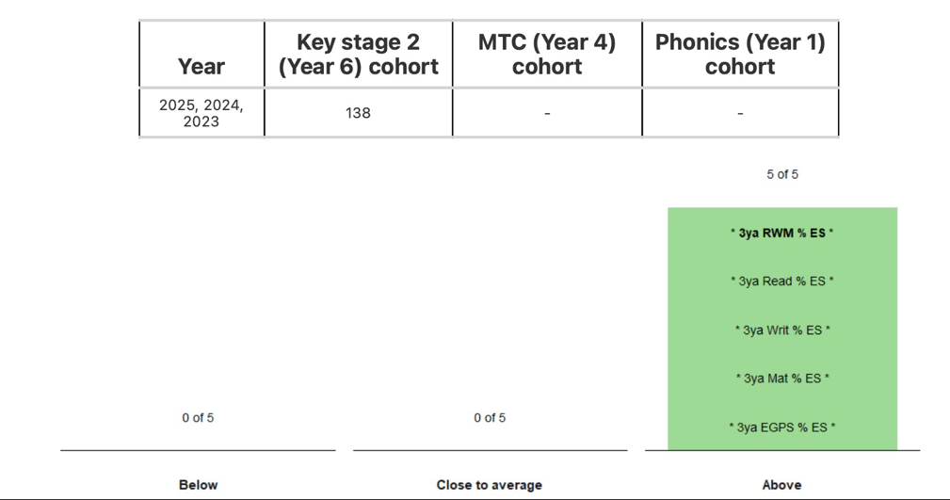
Maths = 56% of pupil premium children met the expected standard

Based on the data detailed above, the performance of our pupil children met some of the intended outcomes identified in the PPG Strategy and have been used to inform intended outcome for the 3-year PPG Strategy by 2027/28.

Overall Review of PPG Strategy - 2022/23 2023/24 2024/25 (see below)
Target 1: Improved phonics attainment in the Year 1 Phonics Screening Check for disadvantaged pupils, and all pupils
As per the previous year, attainment in phonics continues to increase to 77% despite the cohort with a high level of SEN. Out of the pupil premium children, 81% passed the Year 1 PSC. 50% of disadvantaged passed the PSC in the resit in year 2 and 10 children progressed to Year 3 to continue accessing Phonics, this includes 5 children with an EHCP.
Evaluation of PP strategy 3 year target - Achieved as attainment has increased every year, despite a low baseline in EYFS.

Target 2: Improved reading attainment among disadvantaged pupils at the end of KS1 and KS2
In KS1, 29% (Reading), 32% (Writing) and 41% (Maths) of pupil premium children met the expected standard which is lower than national average.
By the end of KS2 results demonstrate higher attainment for our pupil premium children 66% (Reading) 63% (Writing) and 56% (Mathematics) which is higher than national average.

Evaluation of PP strategy 3 year target - Not achieved as attainment outcomes for pupil premium at the end of Key Stage 1 remain significantly below expected for national average.
Target 3 : Improved oral language skills and vocabulary for all pupils, especially the disadvantaged pupils.
Dialogic teaching, alongside development of an ambitious thinking curriculum, remains the relentless focus for all teaching and learning, continuous professional development and school development priorities. Subject leaders ensure that Tier 3 vocabulary is planned for and quality subject specific texts are read within the daily reading lesson to increase exposure to an increased amount of tier 2 and 3 vocabulary.
Evaluation of PP strategy 3 year target - Achieved as children's use of vocabulary has improved as evidenced in the dialogic classroom and since this has been prioritised in retrieval practice.
Target 4: To achieve and sustain improved attendance for all pupils, particularly our disadvantaged pupils.
Attendance, for the duration of this Pupil Premium strategy has remained broadly in line with national averages. Trends for pupil premium children indicate that this is a 2% difference for pupil premium children. This will continue to be a whole school priority and relentless focus for improvement.
Evaluation of PP strategy 3 year target - Achieved as attendance overtime has remained in line with national averages and within 2% for our PPE children.

Target 5 - To achieve and sustain improved well-being for all pupils in our school, particularly our disadvantaged pupils.
Layton's ethos is vision driven from the desire to work successfully with disadvantaged children to prepare them for next steps in education and lifelong learning. There has been a significant increase in both the number, and range, of extra-curricular club provision for all children across all cohorts. The Pupil Leadership Team promote the child's voice regarding well-being in school.
The Family Engagement Team meet the needs of all children and prioritise the needs of all children requiring additional support to access learning successfully.
Evaluation of PP strategy 3 year target -- Achieved this is, and always will be, a key priority for Layton Primary School with a shared understanding that emotional well-being is important for all our pupils as without this, learning will not take place.

Service pupil premium funding (optional)
For schools that receive this funding, you may wish to provide the following information: How our service pupil premium allocation was spent last academic year
At present, we receive additional funding for one service child.

Further information (optional)
Use this space to provide any further information about your pupil premium strategy. For example, about your strategy planning, implementation and evaluation, or other activity that you are delivering to support disadvantaged pupils that is not dependent on pupil premium funding.

