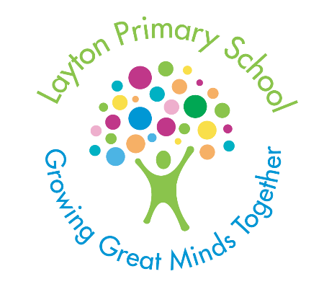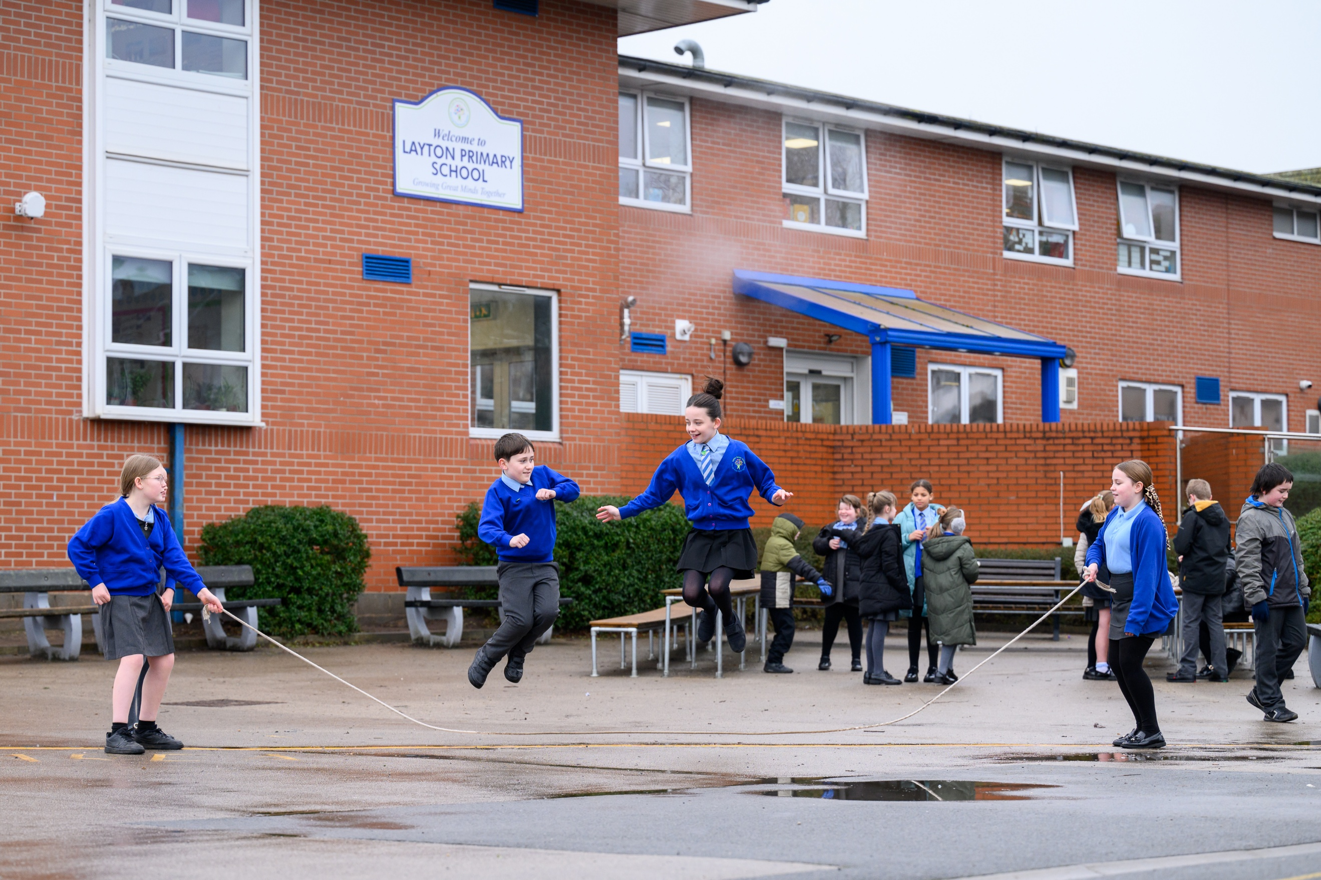

Approved by: C. Scott Date: 31.01.2026
Last reviewed on: January 2026
Next review due by: January 2027

Signed by: Roy Fisher (Chair of Governors) Signed by: Jonathan Clucas (Head Teacher)

Learning to Read and Reading to Learn Policy

Contents:
Section 1: Roles and Responsibilities of the Learning to Read and Reading to Learn Policy……………..Page 3

Section 2: Early Reading and Phonics Policy: Vision/Intent/Implementation/Impact………………………Page 3
- Progression in Phonics and Common Exception Words
- Use and Application of Phonics Knowledge
- Assessment for Learning Strategies:
- Precision Teaching
- Alternative Strategies
- Cued Articulation
- Teaching Sequence.
- Handwriting Program
- Phonics Screening Check
- Continuous Professional Development
- Equality of Opportunity
- EAL Children Accessing Phonics
- Monitoring and Review
..
Section 3: Learning to Read and Reading to Learn Policy: Vision/Intent/Implementation/Impact of concepts and categories of the reading curriculum…………………………………………………………………………Page 8
Concept 1: Learning to read – (i) Phonic knowledge, (ii) Reading fluency, (iii)Reading aloud, (iv) Common exception words.
Concept 2: Reading to learn – (i) Reading for meaning and understanding, (ii) Reading for meaning techniques, (iii) Tier 2 and tier 3 vocabulary instruction, (iv) Constructing and deconstructing text.
Concept 3: Cultural capital – (i) Understanding of different cultures, (ii) Entitlement experiences, (iii) Reading exposure across the curriculum, (iv) Understanding of diversity and inclusivity.
Concept 4: Reading for pleasure – (i) Resilience, (ii) Parental engagement, (iii) Confidence, (iv) Intrinsic motivation.

Appendix 1: Lesson Visit Phonics
Appendix 2: National Curriculum Expectations Word Reading and Comprehension (EYFS to Year 6)
Appendix 3: Reading Diet (EYFS to Year 6)
Appendix 4: Reading Fluency Practice Techniques
Appendix 5: Example of reading half-termly overview
Appendix 6: Types of Reading Aloud
Appendix 6: The Daily Reading Lesson – non-negotiables
Appendix 7: VIPERS visual cues
Appendix 8: The role of the librarian
Appendix 9: Weekly Phonics Plan
Appendix 10: Precision Teaching Protocol

- Roles and Responsibilities for the Learning to Read and Reading to Learn Policy
The headteacher is responsible for:
- Articulating the vision, and strategically planning, for a whole-school reading culture.
- The day-to-day implementation and management of the Learning to Read and Learning to Read Policy (including Phonics and Early Reading) in collaboration with the Reading and Phonics curriculum leaders and Teaching and Learning Curriculum Leader (TLCL).

The Teaching Learning Curriculum Leader, Reading and Phonics curriculum leaders are responsible for:
- Ensuring all teachers, LSAs and SSAs have familiarised themselves with the Learning to Read and Learning to Read Policy (including Phonics and Early Reading).
- Supporting colleagues with the implementation of any aspect of the Policy.
- When required, assist with the planning and selection of new resources.
- Inform staff of any updates to the policy.
- Accept responsibility for daily reading resources and keeping colleagues informed of available resources.
- Liaising with the headteacher, core subject governors and report any developments at half-termly governor meetings.
- Reviewing and analysing class and year group assessment data in order to track pupils’ progress.
- Monitor phonics and reading planning, observing and offering feedback on the teaching of reading fluency, comprehension and phonics.

The class teachers, LSAs and SSAs are responsible for:
- Using assessment for learning strategies such that new learning builds on previous knowledge.
- Ensuring that the discussion with Team Leader informs the weekly planning for skills to be taught.
- Reading the phonics weekly plan and reading half termly overview such that all adults within the year group are aware of the skills being learned by all children; this will support the children using and applying their phonics and reading to learn skills in all subjects.
- Following the agreed structure of the phonics and reading lesson such that children are able to revise, consolidate, extend and apply.
- Adhering to this policy such that children’s opportunities to learn to read and read to learn are optimised at all times and reading is an intrinsic part of the whole school ethos.
Section 2: Early Reading and Phonics Policy
Vision:
Our Vision for Phonics: To create learners that have the phonetic knowledge to be intrinsically motivated to read to learn; embedding and applying phoneme and grapheme knowledge in all aspects of the curriculum.
Aims: Intent
As the DfE has stated that there is no statutory requirement for schools to choose one of the Synthetic Systematic Phonics (SSP) programmes on the validated list (July 2021), our bespoke phonics curriculum, ‘Layton Letters and Sounds’, aims to provide:

- all that is essential to teach SSP to children in Foundation, year 1 and 2, and beyond into Key Stage 2 if required.
- sufficient support for children in Foundation and Key Stage 1 to become fluent readers.
- a structured, systematic approach for most children to meet or exceed the expected standard in the year one Phonics Screening Check.
- all National Curriculum expectations to be taught for word reading through decoding by the end of key stage 1 (DfE, July 2021, Guidance: Choosing a Phonics Teaching Programme).
- a rigorous curriculum that recognises if a child is not progressing through the phonics program, alternative provision is made to suit the specific needs of the individual.

To achieve these aims, it is essential:
- to establish consistent teaching, to maximise progression and continuity in the teaching and learning of phonics throughout the school.
- to provide a language rich environment that encourages and develops oracy (See Dialogic Teaching Progression, June 2026)
- for pupils to use and apply their phonic knowledge in their reading and writing across the whole curriculum, whilst developing cultural capital.
- to have robust formative and summative assessment procedures to regularly check progress and identify pupils in need of intervention.
- to promote reading for pleasure with exposure to a range of texts, fiction and non-fiction as per our ‘Layton Reading Spine’.
- to be flexible in teaching children to read and recognise that if children are not making progress through the Synthetic Systematic Phonics Program, it is vital to use additional strategies to support these children in learning to read (Refer to Precision Teaching Protocol, November 2023).

How is the curriculum delivered ?
The successful implementation of the Phonics curriculum is dependent upon:
  - A clear progression (i) of learning phonemes and common exception words (tricky words),
  - Use and application of phonics knowledge (ii) in all subjects of the National Curriculum.
  - Regular use of formative and summative assessment for learning strategies (iii) to ensure children progress through the acquisition of sounds.
  - Use of spaced learning practice such that children have chance to learn you knowledge, forget and retrieve knowledge from their long term memory on a regular basis.
  - Precision teaching for phonics (iv)and other strategies for those children that fall behind.
  - Alternative strategies (v) for learning to read
  - Cued articulation (vi) to support children understand how, and where, the sounds are formed.
  - A clear teaching sequence (vii) ensures that there is a consistent approach to teaching and learning in phonics throughout KS1 and beyond if required.
  - Children have access to a consistently delivered handwriting program (viii) (See Handwriting Policy).
  - Children have the skills necessary to access the Phonics Screening Check (ix) at the end of year 1.
  - A clear program of Continuous Professional Development (x) ensures high levels of expertise in the quality first teaching of phonics and early reading.
  - Equality of opportunity for all and EAL children (xi) learning to read.
  - Monitoring and review (xii) of the delivery of the synthetic systematic phonic program.

What is the impact of the curriculum?
The successful impact of the Phonic’s Policy will be subject to monitoring and review of teaching and learning and pupil outcomes (blending to read and segmenting to encode). Progress is measured using comparison of the Reception baseline to attainment in the Year 1 Phonics Screening Check. Subsequently, this will be assessed by individual’s reading fluency throughout school. Children who do not pass the Phonics Screening Check in year 1, take the assessment again in year 2 and 3 where necessary.

At Layton, we recognise Phonics is the step up to fluent word recognition. Automatic and effortless reading of all words – decodable and tricky – is the ultimate goal. By repeated segmenting and blending of words, children get to know them, and once this happens, they should be encouraged to read them straight off in reading text, rather than continuing to sound and blend them aloud because they feel that this is what is required. They should continue, however, to use overt or silent phonics for those words which are unfamiliar (see Learning to Read – Reading Diet - section 3).

Teaching and learning in phonics is monitored as part of the Monitoring and Evaluation Policy. All adults teaching phonics will be observed at least twice per year and receive constructive feedback to continually improve outcomes for children.

- Progression in Phonics and Common Exception Words:
Refer to Googledrive/Curriculum/Phonics/Layton’s Letters and Sounds/Stage 1 - 6 for Layton’s Letters and Sounds Curriculum. Included within this, there is weekly reference to the common exception words to learn to read/spell.

Each week, all groups indicate which stage and week of Layton’s Letters and Sounds they are delivering and follow the teaching sequence defined below. Children are given regular opportunity to practise reading and spelling common exception words as part of the daily phonics lessons and in other timetabled opportunities within the day. E.g. Year 2 practise common exception words and GPCs as dictation sentences for 5 minutes every day.

- Use and Application of Phonics Knowledge
Encoding (spelling)
To encode words, children are taught to identify the phonemes in spoken words first. This is also referred to as ‘segmenting’ spoken words. Then they write the graphemes that represent the phonemes.

Children:
1. hear the spoken word ‘dog’
2. say ‘dog’ – /d/ /o/ /g/
3. write the three corresponding graphemes ‘d’, ‘o’, ‘g’ to spell the word ‘dog’.

Children:
1. hear the spoken word ‘goat’
2. say ‘goat’ – /g/ /oe/ /t/
3. write the three corresponding graphemes, ‘g’, ‘oa’, ‘t’ to spell the word ‘goat’.

At Layton we acknowledge that children learn to read more quickly than they learn to spell correctly. This is why their progress in reading must not be held back by whether or not they can spell accurately. The National Curriculum also says that reading and spelling should be taught alongside one another, “so that pupils understand that they can read back words they have spelt”.

At Layton, we recognise the more graphemes children learn to read and write, the more words they will be able to read and spell, and, as they decode unfamiliar words, they encounter new vocabulary.
To use and apply their phonic knowledge, across all curriculum subjects, children need to:
• practise segmenting spoken words into their individual sounds,
• choose which letter or letters to represent each sound,
• respond to dictation from the teacher, practising writing words in sentences that include only the GPCs and exception words they have learnt.
(The Reading Framework, Teaching the Foundations of Literacy, July 2023)

- Assessment for Learning Strategies:
Before children can access a SSP, they must have the fundamental requirements to form speech sounds accurately. A school-based Speech and Language Therapist ensures that as soon as children start in Foundation Stage they are assessed, if necessary, and an individualised learning program put in place such that their speech needs can be met to enable the child to access the SSP at their level.
A
At the heart of securing progression in a SSP, is teacher’s ability to use a range of daily formative assessment strategies to assess the use of certain phonics sounds. This knowledge can be used to target certain individual to use and apply phonics throughout the day in a range of curriculum areas. E.g. Which ai sound shall I use for ‘rain’? Why?
Summative phonics assessments are undertaken regularly (see Layton’s Letters and Sounds, at the end of each stage) so that precision teaching strategies can be targeted for certain children to accelerate progress in the acquisition of phonics sounds. The children are assessed using the Letters and Sounds end of phase assessments. From stage 3, this assessment includes writing the graphemes for the phonemes in addition to reading the graphemes.

- Phonics Precision Teaching:
Whilst we recognise that most children will learn to read using the SSP curriculum, when children aren’t making progress in phonics we seek alternative provision to match the specific needs of the individual child.
In the first instance, if an individual is not retaining the knowledge of certain sounds these sounds can be targeted using precision teaching strategies. This strategy may also be used to secure knowledge of tricky words and year 1 and 2 common exception words. If this system of intensive repetition of certain phonemes and tricky words isn’t successful, discussion of individual’s need must take place with the Team Leader and/or SENDCO and alternative strategies for teaching reading adopted. See Precision Teaching Protocol (Appendix 9).

- Alternative Strategies for teaching reading
Whilst it is valued that most children at Layton will succeed in learning to read through the SSP, all teachers must be aware of the need for alternative strategies to be adopted for children who do not make progress in phonics; after precision teaching methods have been adopted. When considering using additional strategies for individual children, these children need to be discussed with the SENDCO. It is our belief that children displaying dyslexic tendencies will not succeed using SSP. Children with additional needs may need to learn to read through:
- Top-down phonics whereby the teaching of sound-spelling correspondences begins with whole words and progresses from there down to the individual relationships between graphemes and phonemes. Within this category it is recognised that there are two variations: analytic phonics and analogy phonics. In analytic phonics, the repertoire of memorised sight words is analysed to find the constituent sound-spelling correspondences. E.g if pupils memorise the words. ‘Bag’, ‘bin’ and ‘boat’ they can analyse these to see that the grapheme can represent the phoneme /b/. In analogy phonics, pupils attempt to decode unknown words through comparison of the sight words learned. E.g. if pupils have memorised the words ‘bag’ and ‘red’, they can use the implicit sound- spelling correspondence to decode ‘bed’.
- A comprehensive approach to reading by combined study of the appearance, sound, and meaning of words; alongside the daily phonics lesson.

- Cued Articulation:
Cued articulation is a set of hand cues for teaching the individual sounds in a word. The hand movements are logical – each hand movement represents one sound and the cue gives clues as to how and where the sound is produced. All adults that deliver phonics use cued articulation to support blending and segmenting sounds to read (decoding) and spell words (encoding). Children are taught the actions in pairs – for every ‘noisy’ sound there is a matching ‘quiet’ sound. Cued articulation is used to represent phonemes in Stage 2 and 3 of the Layton’s Letters and Sounds.
Whenever staff move year groups from KS2 to KS1, training is given on the use of cued articulation such that this is consistent across the Key Stages.

- Teaching Sequence:
Throughout Foundation Stage and Key Stage 1, and in Key Stage 2 if required, children have access to a 30 minute discrete daily phonics lesson (also see Reading Diet – section 3). Well-planned discrete phonics sessions are taught using the ‘sequence of teaching’ structure:
Revisit and review– recap on previously taught GPCs/tricky words.
Teach/model – teach a new GPC or word.
Practise – provide opportunities to practise saying and reading the sound through games and activities for children.
Apply – apply the new skill to read and write words, captions and sentences.
Opportunities to use and apply the phonic sounds taught are promoted throughout the day, cross-curricular. Dictation is common practice in year 1 and 2 to give children opportunity to use and apply their knowledge of phonic sounds and common exception words.

Through a daily phonics lesson, guided reading, modelled reading and shared reading, children are exposed to at least 1 hour of teaching the different aspects early reading every day (see Early Reading below).

Weekly phonic plans are saved on Googledrive for all teachers, LSAs, SSAs and SLT to access (see appendix 9).
- Handwriting Program:
Throughout school, all children are taught cursive handwriting whereby the letters lead from the line. The narrative used to form each letter is the same in every year group as per the ‘Handwriting Policy’. This letter formation is used in all forms of written work. When the children are exposed to cursive letters for the first time, the printed equivalent letter is provided as a visual cue to what they will see in the printed text. When children are taught a new phoneme in the daily phonics lesson, they are explicitly taught how to write the corresponding grapheme.
- Phonics Screening Check:
In June of year 1, most children access the Phonics Screening Check. If, for whatever reason, a child is disqualified from accessing this test in year 1, they will have access to this in year 2 and beyond if required.
The Phonics Screening Check is only the first step in becoming a fluent reader. Children will still need considerable practice in decoding unfamiliar words speedily and other familiar words ‘at a glance’. At this stage of early reading, children need to build up reading stamina and fluency.
The Standards and Testing Agency advise that: “Approximately 90 words per minute is a good indicator of when children start to read with sufficient fluency to focus on their understanding, but some pupils read slower than this while still being able to do so.” (Teacher assessment frameworks at the end of key stage 1, for use from the 2018/19 academic year onwards)
- Continuous Professional Development:
To ensure the highest expertise in the delivery of phonics and the teaching of early reading, all teachers, LSAs and SSAs have access to training and are actively encouraged to request training as and when required.

To maintain expertise in the delivery of phonics, teachers, LSAs and SSAs have a ‘buddy’ so that they can facilitate personal development. This might include team teaching a phonics lesson, observing each other’s phonics lesson and supporting each other as and when required.
- Equality of Opportunity:
Layton’s Letters and Sounds Curriculum aims to meet the needs of all learners and to ensure that every child gains the phonetic knowledge they need to become a fluent reader.
Teachers set high expectations for all pupils. They will use appropriate assessment for learning strategies to set ambitious targets and plan challenging work for all groups, including:
• More able pupils,
• Pupils with low prior attainment,
• Pupils from disadvantaged backgrounds,
• Pupils with SEND,
• Pupils with English as an additional language (EAL).

- EAL Children Accessing Phonics:
A learner’s first language or languages will have an impact on how quickly and successfully s/he learns to pick up the English phonetic code. The stress and rhythm of a first language will also affect how well learners of English as an Additional Language are able to adapt to the cadence and intonations of English.

For children learning EAL, the most effective way of learning phonics, or breaking the code, is through the practice being embedded in a meaningful task, using familiar materials that children can relate to.
This means using books and stories that children are familiar with as a vehicle for developing phonetic knowledge. For example:
  - Select words from the text that contain sounds you want to focus on, e.g. man.
  - Read the text and ask the children to point out the chosen word, then re-read it and find any others that have the same ‘an’ pattern – e.g. ran, can etc.
  - Make a wall chart with these words on and add to them as the children discover new words that contain the same patterns.
  - Then look for more complex words that have the same phoneme/grapheme links – e.g. hand, land, sand etc.

- Monitoring and Review
The teaching of phonics will be monitored in the following ways:
- Regular observation of the teaching of the discrete daily phonics lesson (see phonic lesson observation – Appendix 1).
- Observation of the use and application of phonics within the literacy lesson and other curriculum subjects.
Pupil progress will be measured by:
- Regular assessment of attainment in phonics as per Layton’s Letters and Sounds curriculum.
- National Reception baseline data and own school baseline data.
- Phonics Screening Check Year 1 (and beyond if required)
Signed Headteacher : ______________________________ Date: January 2026

Review Date: July 2026

Section 3: Learning to Read and Reading to Learn Policy
Vision: To create fluent readers, within a culture of reading for pleasure, such that children read to learn in all aspects of the curriculum.
Aims: Intent:
- Children learn to read fluently as quickly as possible. Inevitably, fluent readers will learn more, because they can read and gain knowledge for themselves.
- Children access quality first teaching of early reading ensuring that all children learn to read early, regardless of their background.
- A rigorous focus on the lowest attainers, and early recognition of children that are not making progress in SSP, aims to identify children that need specific support to make accelerated reading progress.
- Children with special educational needs are identified such that barriers to learning are removed.
- Children are immersed in a reading culture that evokes a love of reading from the moment they start in Foundation Stage.
- Children’s prior knowledge and experiences should be built on, valued and harnessed to support them in making links and connections.
- Children should experience appropriate, high quality literature from the very beginning as the best way of developing positive attitudes to reading, whilst simultaneously expanding their vocabulary and broadening their knowledge and understanding of the world through exposing them to experiences to enhance cultural capital.
- Create a rich, inspiring, organised and safe reading environment in which children can browse, select and enjoy books.
- Every time a child encounters a text, their instinct is to derive meaning from the text as they read.
- Children’s creativity, imagination and critical thinking can be ignited by a rich reading diet.
- Children have an interest in words, how they work and their meanings to support both their spelling and their language choices - striving towards a rich and aspirational vocabulary for all.
- Pupils hear texts read aloud daily, including a range of genres and themes.
- Development of speaking and listening skills is a fundamental element of learning to read and is a skill for life.
- Parents/carers have an essential role in developing children’s reading skills and love for reading.

The Reading curriculum embeds the concepts and categories of:
  - Learning to read – Phonic knowledge, Reading fluency, Reading aloud, Common exception words.
  - Reading to learn – Reading for meaning and understanding, Reading for meaning techniques, Tier 2 and tier 3 vocabulary instruction, Constructing and deconstructing text.
  - Cultural capital – Understanding of different cultures, Entitlement experiences, Reading exposure across the curriculum, Understanding of diversity and inclusivity.
  - Reading for pleasure – Resilience, Parental engagement, Confidence, Intrinsic motivation.

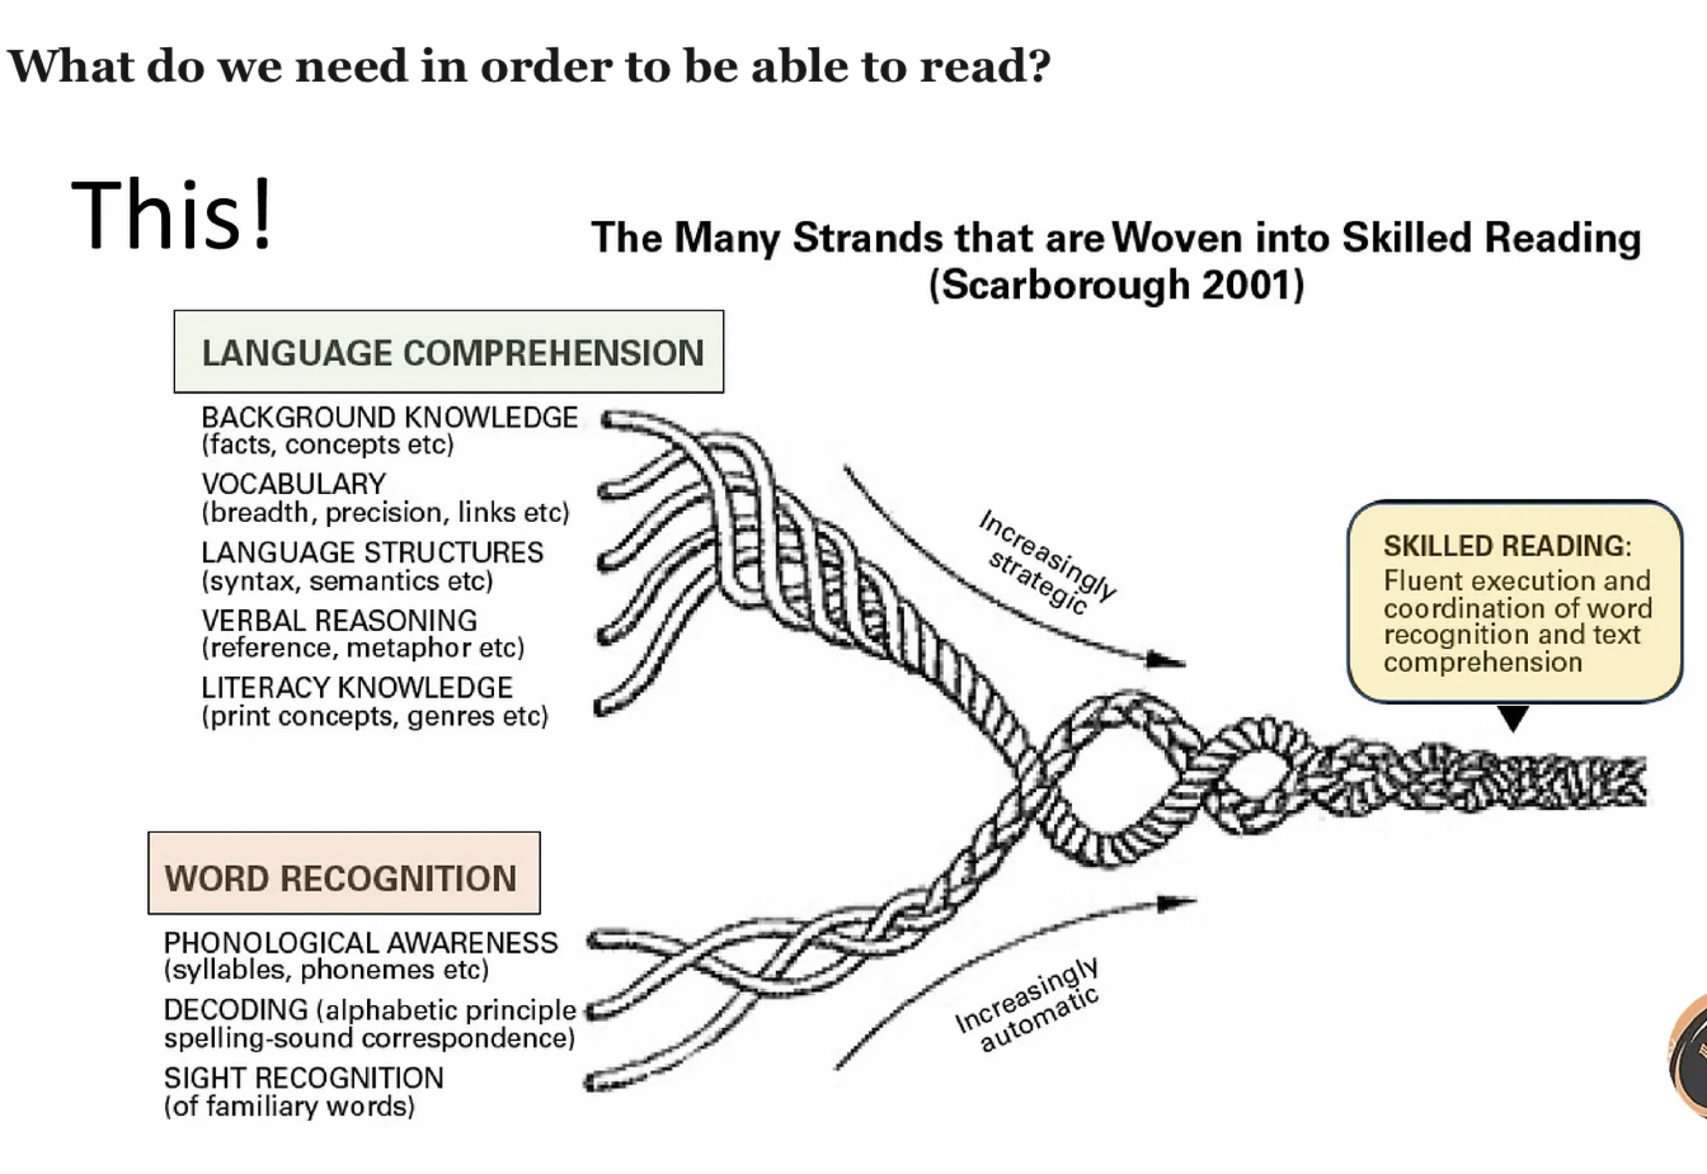
All these concepts and categories have to be intertwined if children are to become life-long readers.
Implementation:

Concept 1: Learning to Read

- Category 1 - Phonic Knowledge

The explicit teaching of phonic knowledge encompasses phonic decoding skills and the quick recognition of common exception words (refer to Early Reading and Phonics Policy in Section 1)

Access to Phonics Teaching in Key Stage 2

Throughout school, children access phonics teaching until they are secure at phase 5. As the children progress to KS2, this will take the form of intervention groups and/or precision teaching for specific sounds. These children will have access to a home reader book that is at their level of phoneme knowledge.

Individual Reading books
Throughout Foundation Stage and KS1, every individual’s reading book is closely matched to the phonic sounds/stage that each child accesses in their daily phonics lesson, fully decodable until they are at the end of stage 5 of the SSP. Pupils are expected to practise reading and re-reading books that match the grapheme-phoneme correspondences they are learning. These books match their blending ability e.g. if they are learning stage 3 sounds but can only blend stage 2 sounds, their home reader should be matched to stage 2.

These phonetically decodable books are taken home daily, and returned to school daily, and changed regularly throughout the week. The child’s home reader should be read independently to an adult. Some books are ‘partner’ texts which indicate the role of the adult and child in sharing the book.

A class record of 1:1 reading and reading at home is kept using the app Boom Reader such that those children that do not read with an adult at home can be targeted for support within class. This additional reading support is provided by the class teacher or learning support assistant. All children throughout school read with their teacher at least once per week, each teacher keeps a record of this using Boom Reader. The bottom 30% of the cohort are read with every day. This is monitored by the Teaching and Learning Curriculum Leader on a regular basis.

Alongside this, the children choose their own book from the library (see below Reading for Pleasure)

- Category 2 - Reading Fluency

At Layton Primary School, we recognise that reading fluency is the pre-requisite for the comprehension (reading to learn) that is the purpose of all reading and this requires regular practise to master accuracy, automaticity and prosody. Fluent reading is acquired through frequent decoding; it is this allows the spellings of words to become ‘glued’ to the pronunciations already stored in a reader’s memory (Harm, 2004).

Reading fluency is based on the frequent practice of sound-spelling correspondences and phonemic awareness skills such that children read with accuracy, that is, reading where errors are rare.

Reading fluency practice is taught whenever the children are exposed to a text (see Reading Diet appendix 3) and explicitly taught within the “Daily Reading Lesson’ (See Appendix 5).

The strategies for promoting reading fluency include: repeated oral reading, extended reading, close reading and shared reading (see Appendix 4).

Within these strategies, children are explicitly taught the skills of reading aloud specifically prosody whereby children read with intonation (the rise and fall in tone), stress (the prominence given to particular syllables, words or phrases and rhythm. Prosody is the ability to read in a way that mirrors the sounds of natural spoken language. At Layton it is a recognised that reading aloud is a vital element of learning to read.

- Category 3 - Reading aloud

As part of the ‘Reading diet’, children experience adults modelling reading aloud via a variety of strategies:

Modelled reading is the strategy used when introducing books for the first time and leaves the text to weave it’s own magic. Shared reading is used when the book is more familiar to the children and they are expected to engage
In particular words and phrases and respect the pauses for example when re-reading a story. Close reading and extended reading provides the opportunity for the children to practise reading fluency using and applying the reading skills within the daily reading lesson. Independent reading is practised when a child reads 1:1 with an adult or a reading buddy.

Adults Selecting a Modelled/Shared Reading Text:
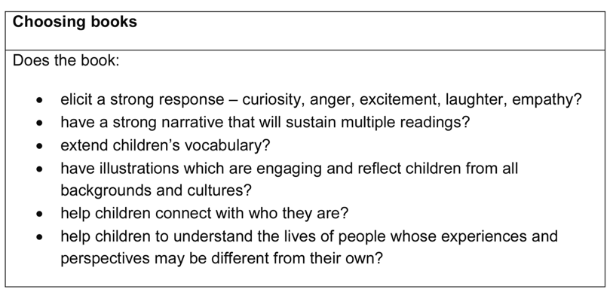
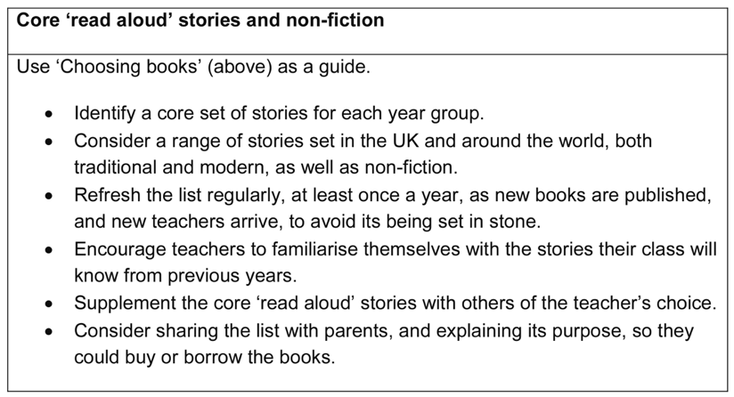
When selecting a text for modelled/shared reading, the teacher must consider how it can be used to: demonstrate a love and passion for reading; make connections between child’s own knowledge and experience; demonstrate
fluency, rate and prosody; provide examples of new and interesting vocabulary; develop listening comprehension; support the discussion around character, plot or resolution development; develop an awareness of different styles of writing (i.e. story beginnings, literary effects, writer's craft) and forms of texts; introduce texts with increasing complexity and abstract concepts; provide content or ideas that will generate critical thinking.

(The Reading Framework, Teaching the Foundations of Literacy, July 2023)

Adults selecting a reading text for the daily reading lesson
The daily reading lesson provides opportunities for children to practise reading fluency (prosody, automaticity and accuracy), engage in explicit vocabulary instruction and immersion in comprehension instruction strategies. Selecting this text will depend upon the type of fluency practice to be used within the lesson. This high-quality text might be from the class novel/story (Monday, Wednesday, Friday), a reading text from a foundation curriculum subject (Tuesday and Thursday).

As a guide, around half of the reading children undertake should be narrative fiction. The other half should be composed of poetry, drama, narrative non-fiction (e.g. biographies) and expository texts (e.g. factual reports, speeches, newspaper articles, advertisements, letters etc.

The text should be pitched at or just beyond the current abilities of the more able readers in class. Class teachers should also consider the diversity of backgrounds and experiences that is reflected back at children when they read texts in reading lessons or when class novels are shared.

Structure of the Daily Reading lesson (Refer to Appendix 5 and Concept 2: Reading to learn)

- Category 4 - Common exception words

Common exception words are explicitly taught to support reading fluency through whole word recognition. Within EYFS, common exception words are called ‘tricky words’ as they do not follow the rules of phonics. In KS1 and KS2, the children are explicitly taught to read and spell these words and practise these through dictation. This is planned as part of the Layton’s Letters and Sounds SSP.

Concept 2: Reading to learn

Comprehending a text intertwines language comprehension – comprehension knowledge, background knowledge, vocabulary, inference and knowledge of text structures. All these reading to learn strategies are based on quality interactions between teachers and children through direct teaching and engagement in high quality dialogue to interrogate the text.

From year 1 to year 6, children access a ‘Daily Reading Lesson’ (Appendix 5) that incorporates reading fluency practice, vocabulary instruction (incorporating morphology and etymology), and a range of techniques to support deriving meaning from the text through comprehension strategy instruction.

- Category 1 - Reading for meaning and understanding

Every time the children encounter a text, the primary aim is for the child to derive meaning from the text. Reading comprehension is the process of constructing a model of what we understand from the text whilst in the process of reading it. This is sometimes referred to as a ‘situation model’. It is necessary to to support the children with strategies to update their situation model for the text as they read such that they retain the essential information to derive meaning from the text. A strategy to support this is mind mapping so that children can record a visual summary of the text.

Teaching the children the need to make inferences is an essential part of comprehending a text however it is a skill that relies on knowledge of words and syntax, knowledge of the world and knowledge of text structures. Children’s inference skills are improved by teaching a broad, carefully planned curriculum which questions and discusses the vocabulary (pronouns and connectives) and by teaching children different text structures.

(ii) Category 2 - Comprehension strategy instruction

Comprehension strategy instruction needs to be integrated within the daily reading lesson alongside all other methods to support deriving meaning from the text. At times, these skills will need to be explicitly taught and scaffolded such that this becomes an integral element of questioning and discussions within close reading and extended reading sessions.

There are two types of questions in reading sessions are to establish meaning or analyse meaning. When planning questions to ask the children, It is necessary to consider a text at different levels – word/phrase/sentence level and paragraph or text level. The high quality questions should support the specific genre of text being read, supplementary questions are used to promote critical thinking.

The proportion of the lesson spent on comprehension strategy instruction will depend on the type of fluency practice undertaken.
  - Repeated oral reading – questioning and discussion mostly reserved for before and after reading to allow focus on developing fluency.
  - Extended reading – around one third of the session is spent discussing the text – questioning/vocabulary instruction at keep points pre-planned by the teacher.
  - Close reading – two thirds of the session to be spent in rich discussion about the text.
  - Shared reading – brief discussion of meaning and vocabulary – main focus is enjoyment and flow if the text.

- Category 3 - Tier 2 and tier 3 vocabulary instruction

It is recognised that explicit vocabulary instruction, of tier 2 and 3 words, is an essential pre-requisite of our children developing skills to read to learn. As well as explicit instruction, vocabulary instruction includes in-the-moment teaching as children encounter unfamiliar words in any text. Please note that the teaching of these words is synchronised with the wider curriculum.

Tier 2 vocabulary is explicitly taught from the list as per the list of 345 tier 2 words to be taught between the ages of 7-11 (Such, 2021) and is identified on class teacher’s half-termly reading overview (see Appendix 5).

An important element of vocabulary instruction is teaching of morphology and etymology.

Direct vocabulary instruction is delivered by:

        - A child friendly definition is given.
        - The word is put into context by the adult and/or child, ensuring to incorporate the homonyms for the word e.g. bark, second
        - Children are exposed to the word in a text multiple times.
        - At a later date, children ‘retrieve’ the word and use in a spoken sentence or in writing.

(iv) Category 4 - Constructing and deconstructing text

Through the construction and deconstruction of text children identify how language, sentence structure, and presentation contribute to deriving meaning from the text. For children to become fluent readers they need both: phonological awareness, to be able to hear the differences between words and sounds, and the knowledge of print to connect the visual, auditory and oral systems.

These skills are taught when modelling reading in whole-class session, the daily reading lesson, sharing a book for pleasure and within a print rich environment. All classrooms have a reading area to support immersion in the knowledge of print and encourage reading for pleasure.

Children are taught: Knowledge of print
- Concepts of text
  - Understanding that print relays a message.
  - Book handling - holding the book the right way up.
  - Front cover, back cover, title, author, illustrator, blurb.
- Directionality
  - Beginning at the front of the book, ending at the back
  - Turning pages right to left.
  - Concept of top and bottom of a page - beginning at the top of the page and ending at the bottom of the page.
  - Reading pages from left to right.
  - Reading words from left to right.
  - Return sweep - reading left to right then sweep back to the beginning of the following line of text.
- Mechanics
  - Knowledge that words are separated by spaces.
  - Recognising the difference between symbols including, alphabetic letters vs numerals vs punctuation
  - The purpose of punctuation and capital letters.
  - Understanding that most printed words are read the same way each time (e.g. w-o-u-l-d will always be 'would') so there is no need to decode.
- Alphabet knowledge
  - Knowledge of the names of each letter,
  - the order of the alphabet,
  - recognition of each upper and lower case letters,
  - knowing the difference between letters and words.
  - Knowledge of cursive form and printed form of letters (must be taught alongside each other)

Children are taught: knowledge of text structure.

Most written text is planned in advance and conforms to a specific structure that exist to support establishing the meaning of the text. Written text can be divided into two groups: informational texts and literature texts.
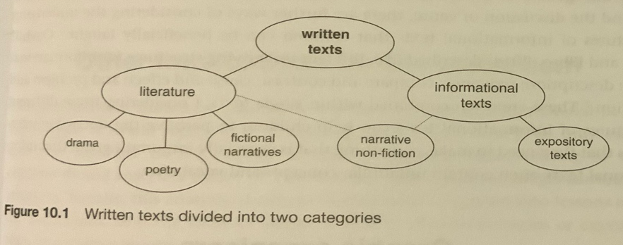
(The Art and Science of Teaching Primary Reading, Such 2021)
Children are taught about the typical text structure of the two forms of written texts.

Structure of literature, children are taught:
- The unique features of fairy tales, creation myths, mystery stories etc
- The concept that stories have a beginning, middle and end usually with conflict, rising stakes and resolution.
- Different sentence structures have a different impact on the reader e.g. metaphor and simile for description, short sentence for suspense etc.
- Specific genres have specific text features e.g. short sentences, flashbacks, etc.

Structure of informational texts, children are taught:
- The unique features of newspapers, biographies, journalistic articles, advertisements, brochures, speeches etc
- That certain information texts have certain features e.g. glossary, contents, index, diagram etc.
- Text structure unique to each genre of information text.

Concept 3: Cultural Capital

- Category 1 - Understanding of different cultures
Layton Reading spine exposes children to a range of texts from different cultures to increase background knowledge to use and apply across the curriculum. These texts are accessed across the curriculum.

- Category 2 - Entitlement experiences
At Layton children learn a carefully sequenced curriculum full of knowledge that has been purposefully chosen, with worthwhile links within subjects and between subjects. There is strong evidence to suggest that a reader’s background knowledge supports their ability to comprehend meaning. Layton’s ‘Entitlement Curriculum’ aims to enrich the curriculum such that the children have improved background knowledge of the world to use and apply when learning to read and reading to learn.

- Category 3 - Reading exposure across the curriculum and (iv)Category 4- Understanding of diversity and inclusivity.

Layton Reading Library (stories/rhymes/poems children access throughout the curriculum)
The ‘Layton Reading Library’ includes a range stories, poems, rhymes and non-fiction and are chosen to develop pupils’ vocabulary, language comprehension and love of reading. Children have access to modelled reading, shared reading, guided reading and immersion in a print rich environment where independent reading can be practised.

The books are carefully chosen for a variety of themes including:
Classic Text and Traditional Texts
These texts are the traditional texts that you expect children to read and re-read such that they can retell the story to others. The selection of classic texts are those that have lasted the test of time and are the texts that were considered ground-breaking for their era.
Texts to highlight Moral Dilemmas
These texts expose children to a variety of situations in which a difficult choice has to be made. Examples of this include: good versus evil, solitude, revenge, crime, corruption, survival, courage, heroism, tackling prejudices, racism and stereotypes, honesty, and loyalty.
Texts to reflect our School Values
These texts will immerse our children in situations where they have to consider our core school values including resilience, relationships, risk-taking, resourceful, reflective. For example, love, friendship, hope, empathy, charity, citizenship, integrity, humility,
Texts to raising awareness of Cultural Diversity and Inclusivity
These texts raise awareness of, be respectful towards and embrace the variety of diverse aspects of humanity. This includes: race, religion, ethnicity, age, gender identity and expression, ability and disability, politics or class.

Each year group have a core set of non-negotiable texts that they read and re-read within that year group. These texts get progressively more challenging across the year. In Key Stage 1, these are the texts that they read and re-read until children know the text inside and out. In KS2 this will facilitate quality book talk at different opportunities throughout the school day.

The reading library is reviewed on a regular basis and within this, there are books identified for science, history, geography, RE and PSHE.

Refer to Appendix 2 for National Curriculum expectations in word reading (EYFS to Year 6).

Concept 4: Reading for Pleasure
- Category 1 - Resilience
The children have access to a print and language rich environment such that they are equipped with the resources required to learn to read and read to learn. Adults advocate that learning to read requires perseverance and frequently model how difficulties in reading can be overcome.

Regular discussion between home and school ensure that the child’s perseverance in learning to read is valued by all and reading progress is reported at Parent’s Evenings.

- Category 2 - Parental engagement
In developing a whole school reading culture, we must engage our parents in the reading process and share the key skills required to develop reading fluency. Every year group holds a ‘Book n’ Brew’ event in the autumn term to demonstrate reading techniques that will support their child become a fluent reader.

Once per half term, each year group is invited to attend the ‘Reading Café’ to enjoy a book in a relaxed environment with all adults in school invited too.

- Category 3 - Confidence
Within the dialogic teaching classroom, children are given every opportunity to develop confidence in reading aloud. This happens as daily classroom practise. Other opportunities to develop confidence when reading aloud include:
- Daily phonics lessons,
- Reading work to other teachers and SLT,
- Reading to a peer in the book corner,
- Reading aloud across all subject areas.

- Category 4 - Intrinsic Motivation
At Layton children are immersed in the love of reading at every opportunity. To maximise motivation of children to engage in reading, all adults within the classroom must emanate a love of reading at all times – valuing book talk, making reading a priority, establishing systems for maximum engagement with reading throughout the day and beyond.

Alongside the phonetically decodable book, the children choose a book for ‘pleasure’ which might be beyond their phonic sound capability. It is the expectation that this book is shared with an adult at home for ‘enjoyment’ and to ‘reflect their interests’.

Children are expected to recommend books that they have read to their peers, giving reasons for their choices. This is an expectation throughout school and is modelled in EYFS and KS1 until they can do this independently.

Reading Incentives
Every week, a child in each class is nominated for ‘Bookworm of the Week’ in recognition of any aspect of reading. Children receive a certificate, sticker and are invited to attend a celebration of their award with other members of staff.

Each half-term, a child in each class is nominated for ‘Bookworm of the Half-term’, this accolade is rewarded by each child ordering a favourite book to take home.

Reading Breakfast Book Club is held weekly before school, whereby parents, and other family members, are invited into school to share a brew, book and biscuit with their child(ren).

Book Corners/ Year Group Libraries
In every classroom, children have shared responsibility for a book corner. At the start of the academic year, the children establish expectations for using the book corner. The class teacher ensures that the children have access to familiar fiction texts, poems, non-fiction books linked to specific subjects and texts chosen as a result of the children’s interests. Book corners are accessed by every child in their preferred way: role play a story using puppets, retell a familiar story, read independently, share a book with a friend.

Throughout school, each class has two librarians with specific duties (see Appendix 8).

Impact:
Monitoring and Evaluation of the Reading Curriculum

The impact of the Reading Curriculum is monitored using a range of formative and summative assessment strategies.

Phonics is assessed daily using formative assessment techniques and summative assessment is as an on-going process throughout the stages of Layton’s Letters and Sounds (refer to Phonics Policy above). Each phonics assessment is saved to the child’s reading folder on Showbie such that progress can be monitored throughout school.

Reading fluency is assessed at two points of the academic year, Spring 1 and Summer 2, and informs direct teaching for the children in early reading strategies to be targeted in modelled reading or when working 1:1 with a child. During a reading fluency assessment (Collins Reading Fluency Assessment) each child is recorded reading for 1 minute at their reading level and then the percentage of words read accurately calculated. Each voice recording is saved within the child’s folder on Showbie such that progress in reading fluency can be tracked through school.

Reading comprehension is not assessed until the child is a fluent reader and on-going formative assessment determines the comprehension skills to be taught. Summative assessment in reading comprehension is undertaken twice a year, Autumn 2 and Summer 1 using the NFER standardised assessments for Reading Comprehension.

Both assessments in reading fluency and comprehension informs teacher’s summative judgements, at Spring 1 and Summer 2, as to whether a child is working towards, expected or at greater depth within the year’s Curriculum they are being taught.

Signed: ______________________________
Headteacher: _________________________

Date:_January 2026
Review Date: July 2026

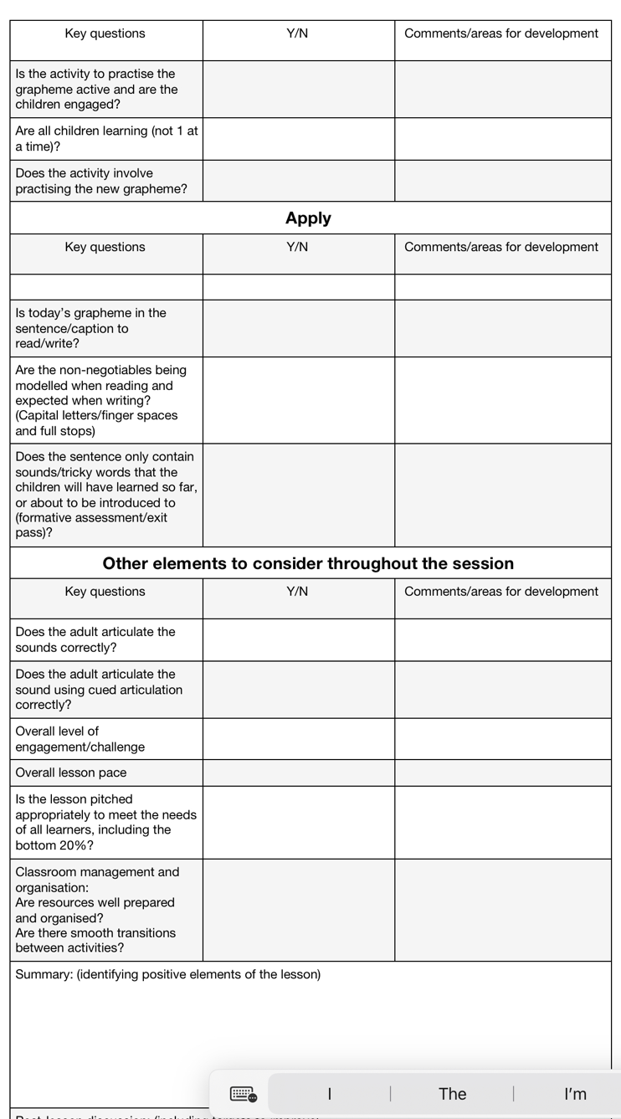
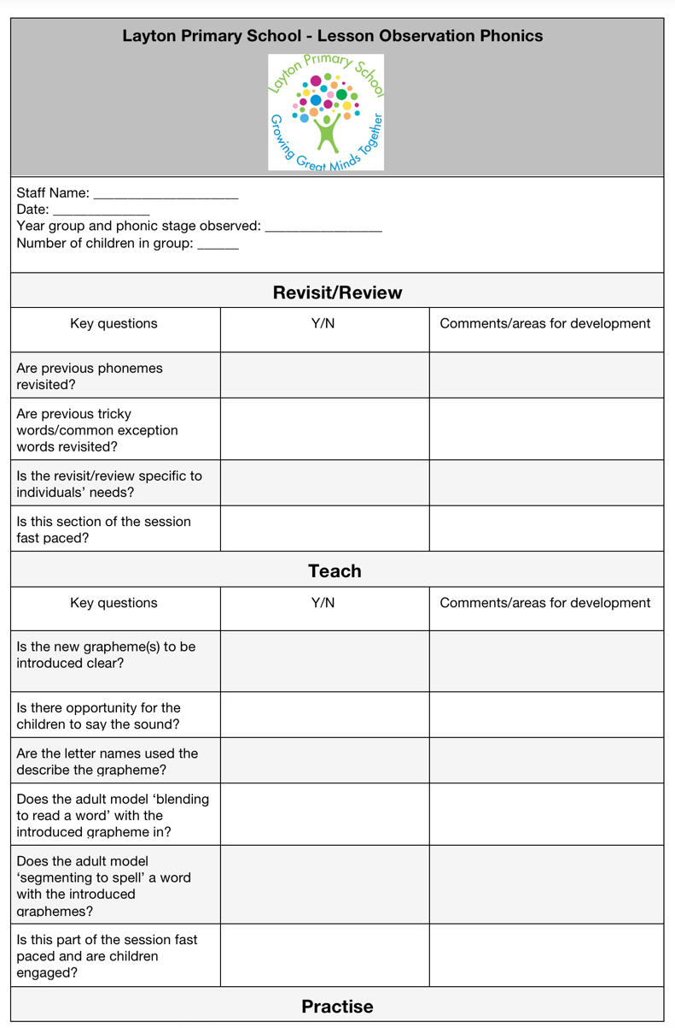
Appendix 1: Lesson Observation -Daily Phonics Lesson

Appendix 2: National Curriculum Word Reading and Comprehension Objectives:

EYFS - Word Reading ELG
Children at the expected level of development will:
- Say a sound for each letter in the alphabet and at least 10 digraphs;
- Read words consistent with their phonic knowledge by sound-blending;
- Read aloud simple sentences and books that are consistent with their phonic knowledge, including some common exception words.

Year 1 – Word Reading
Letters and Sounds Phases 4 to 5.
- Respond speedily with the correct sound to grapheme for the 44 phonemes.
- Recognise and use the different ways of pronouncing the same grapheme; e.g. ow in snow and cow.
- Read accurately by blending sounds in unfamiliar words.
- Read words containing –s, -es, -ing, -ed, -er, -est endings.
- Split two and three syllable words into the separate syllables to support blending for reading.
- Read words with contractions e.g. I’m, I’ll, we’ll and understand that the apostrophe represents the omitted letter.
- Automatically recognise approximately 150 high frequency words (i.e. tricky words and Year 1 Common Exception words).
- Apply phonic knowledge for reading.
- Read aloud accurately books that are consistent with their developing phonic knowledge.
- Develop fluency, accuracy and confidence by re-reading books.
- Read more challenging texts using phonics and high frequency word recognition.

Year 2 – Word Reading
Letters and Sounds Phase 6.
- Apply phonic knowledge and skills to read words until automatic decoding has become embedded and reading is fluent.
- Read accurately by blending the sounds in words, especially recognising alternative sounds for graphemes.
- Read accurately words of two or more syllables that contain alternative sounds for grapheme e.g. shoulder, roundabout, grouping.
- Read words containing common suffixes e.g. –ness, -ment, -ful, -ly.
- Read further common exception words, noting tricky parts.
- Read frequently encountered words quickly and accurately without overt sounding and blending.
- Read aloud books closely matched to their improving phonic knowledge, sounding out unfamiliar words accurately, automatically and without undue hesitation.
- Re-read these books to build up their fluency and confidence in word reading.
- Uses tone and intonation when reading aloud.
- Read longer and less familiar texts independently.

Year 3 and 4 – Word Reading
Pupils should be taught to:
- apply their growing knowledge of root words, prefixes and suffixes (etymology and morphology) as listed in - see English appendix 1 , both to read aloud and to understand the meaning of new words they meet
- read further exception words, noting the unusual correspondences between spelling and sound, and where these occur in the word

Year 5 and 6 – Word Reading
Pupils should be taught to:

- apply their growing knowledge of root words, prefixes and suffixes (morphology and etymology), as listed in English appendix 1, both to read aloud and to understand the meaning of new words that they meet

EYFS - Comprehension ELG:
Children at the expected level of development will:
- Demonstrate understanding of what has been read to them by retelling stories and narratives using their own words and recently introduced vocabulary;
- Anticipate – where appropriate – key events in stories;
- Use and understand recently introduced vocabulary during discussions about
stories, non-fiction, rhymes and poems and during role-play.

Year 1 – Comprehension
Develop pleasure in reading, motivation to read, vocabulary and understanding by:
- Listening to a range of texts at a level beyond that at which they can read independently including stories, non-fiction and poems. §Identifying and discuss the main events in stories.
- Identifying and discuss the main characters in stories.
- Recalling specific information in texts.
- Recognising and join in with language patterns and repetition. §Use patterns and repetition to support oral retelling. §Reciting rhymes and poems by heart.
- Relating texts to own experiences.
- Re telling familiar stories in a range of contexts e.g. small world, role play, storytelling.
- Make personal reading choices and explain reasons for choices.
Understand both the books they can already read accurately and fluently and those that they listen to by:
- Introducing and discussing key vocabulary.
- Activating prior knowledge e.g. what do you know about minibeasts?
- Checking that texts make sense while reading and self-correct.
- Making predictions based on what has been read so far.
- Make basic inferences about what is being said and done.
- Discussing the title and how it relates to the events in the whole story e.g. Peace at Last by Jill Murphy.
Participating in discussion about what is read to them, taking turns and listening to what others say by:
- Listening to what others say.
- Taking turns.
- Giving opinions and supporting with reasons e.g. Hansel was clever when he put stones in his pocket.
- Explaining clearly their understanding of what is read to them.
- Demonstrating understanding of texts by answering questions related to who, what, where, when, why, how.

Year 2 - Comprehension
Develop pleasure in reading, motivation to read, vocabulary and understanding by:
- Listening to a range of texts at a level beyond that at which they can read independently including stories, non-fiction, and contemporary and classic poetry.
- Sequencing and discussing the main events in stories.
- Learning and reciting a range of poems using appropriate intonation.
- Retelling a wider range of stories, fairy tales and traditional tales.
- Read a range of non-fiction texts including information, explanations, instructions, recounts, reports.
- Discussing how specific information is organised within a non-fiction text e.g. text boxes, sub-headings, contents, bullet points, glossary, diagrams.
- Identifying, discussing and collecting favourite words and phrases.
- Recognising use of repetitive language within a text or poem e.g. run, run as fast as you can and across texts e.g. long, long ago in a land far away...
- Make personal reading choices and explain reasons for choices.

Understand both the books they can already read accurately and fluently and those that they listen to by:
- Introducing and discussing key vocabulary within the context of a text.
- Use morphology to work out the meaning of unfamiliar words e.g. terror, terrorised.
- Activating prior knowledge and raising questions e.g. What do we know? What do we want to know? What have we learned? ▪Checking that texts make sense while reading and self-correct.
- Making predictions using evidence from the text.
- Making inferences about characters and events using evidence from the text e.g. what is a character thinking, saying and feeling?

Participating in discussion about what is read to them, taking turns and listening to what others say:

- Making contributions in whole class and group discussion.
- Listening and responding to contributions from others.
- Giving opinions and supporting with reasons e.g. Was Goldilocks a good or bad character?
- Considering other points of view.

Explaining clearly their understanding of what they read themselves and what is read to them:
- Demonstrating understanding of texts by asking and answering questions related to who, what, where, when, why, how.

Year 3 and 4 – Comprehension
Pupils should be taught to:

- develop positive attitudes to reading, and an understanding of what they read, by:
- listening to and discussing a wide range of fiction, poetry, plays, non-fiction and reference books or textbooks
- reading books that are structured in different ways and reading for a range of purposes
- using dictionaries to check the meaning of words that they have read
- increasing their familiarity with a wide range of books, including fairy stories, myths and legends, and retelling some of these orally
- identifying themes and conventions in a wide range of books
- preparing poems and play scripts to read aloud and to perform, showing understanding through intonation, tone, volume and action
- discussing words and phrases that capture the reader’s interest and imagination
- recognising some different forms of poetry [for example, free verse, narrative poetry]

- understand what they read, in books they can read independently, by:
- checking that the text makes sense to them, discussing their understanding, and explaining the meaning of words in context
- asking questions to improve their understanding of a text
- drawing inferences such as inferring characters’ feelings, thoughts and motives from their actions, and justifying inferences with evidence
- predicting what might happen from details stated and implied
- identifying main ideas drawn from more than 1 paragraph and summarising these
- identifying how language, structure, and presentation contribute to meaning
- retrieve and record information from non-fiction
- participate in discussion about both books that are read to them and those they can read for themselves, taking turns and listening to what others say

Year 5 and 6 – Comprehension
Pupils should be taught to:

- maintain positive attitudes to reading and an understanding of what they read by:
- continuing to read and discuss an increasingly wide range of fiction, poetry, plays, non-fiction and reference books or textbooks
- reading books that are structured in different ways and reading for a range of purposes
- increasing their familiarity with a wide range of books, including myths, legends and traditional stories, modern fiction, fiction from our literary heritage, and books from other cultures and traditions
- recommending books that they have read to their peers, giving reasons for their choices
- identifying and discussing themes and conventions in and across a wide range of writing
- making comparisons within and across books
- learning a wider range of poetry by heart
- preparing poems and plays to read aloud and to perform, showing understanding through intonation, tone and volume so that the meaning is clear to an audience

- understand what they read by:
- checking that the book makes sense to them, discussing their understanding and exploring the meaning of words in context
- asking questions to improve their understanding
- drawing inferences such as inferring characters’ feelings, thoughts and motives from their actions, and justifying inferences with evidence
- predicting what might happen from details stated and implied
- summarising the main ideas drawn from more than 1 paragraph, identifying key details that support the main ideas
- identifying how language, structure and presentation contribute to meaning
- discuss and evaluate how authors use language, including figurative language, considering the impact on the reader
- distinguish between statements of fact and opinion
- retrieve, record and present information from non-fiction
- participate in discussions about books that are read to them and those they can read for themselves, building on their own and others’ ideas and challenging views courteously
- explain and discuss their understanding of what they have read, including through formal presentations and debates, maintaining a focus on the topic and using notes where necessary
- provide reasoned justifications for their views

Appendix 3: Reading Diet

Year Group | Reading Diet
Foundation | Phonics  (30-45 minutes daily - daily phonics lesson and end of the day etc)  Modelled/Shared Reading  (30 minutes per day) Children can see the text on the screen such that they develop the concept of words and their understanding of print conventions e.g. reading from left to right and top to bottom of the page.  One to one reading  Once per week when classroom provision permits  Bottom 20% 1:1 reading everyday  Exposure to texts in all subject areas  Refer to Layton Reading Library for the book choices to include whole novels, non-fiction, poetry and graphic novels chosen for a particular theme or curriculum subject.
Year 1 | Phonics  (30-45 minutes daily - daily phonics lesson and end of the day etc)  Guided Reading lesson  (30 minutes per day whole class)  Children undertake fluency practice to learn to read (repeated oral reading/extended reading/closed reading/shared reading) and reading to learn (focus on vocabulary/deconstructing the text to derive meaning)  One to one reading  Once per week when classroom provision permits/bottom 30% every day  Exposure to texts in all subject areas  Refer to Layton Reading Library for the book choices to include whole novels, non-fiction, poetry and graphic novels chosen for a particular theme or curriculum subject.  Modelled/Shared Reading  (15minutes per day) Children enjoy listening to a text read aloud by their class teacher.
Year 2 | Phonics  (30-45 minutes daily - daily phonics lesson and end of the day etc)  Extra precision teaching for children who haven’t past Phonics Screening Check)  Guided Reading lesson  (30 minutes per day whole class)  Children undertake fluency practice to learn to read (repeated oral reading/extended reading/closed reading/shared reading) and reading to learn (focus on vocabulary/deconstructing the text to derive meaning using a variety of comprehension strategies - VIPERS)  One to one reading  Once per week when classroom provision permits/  bottom 30% every day  Exposure to texts in all subject areas  Refer to Layton Reading Library for the book choices to include whole novels, non-fiction, poetry and graphic novels chosen for a particular theme.  Modelled/Shared Reading  (15minutes per day) Children enjoy listening to a text read aloud by their class teacher.
Year 3 to 6 | Phonics  Daily intervention until secure at the end of stage 5  (30 minutes daily)  Daily Reading lesson  (30 minutes per day whole class)  Children undertake fluency practice to learn to read (repeated oral reading/extended reading/closed reading/shared reading) and reading to learn (focus on vocabulary instruction/deconstructing the text to derive meaning)  One to one reading  Once per week when classroom provision permits/  bottom 30% every day with an adult/reading buddy  Exposure to texts in all subject areas  Refer to Layton Reading Library for the book choices to include whole novels, non-fiction, poetry and graphic novels chosen for a particular theme. Refer to the Foundation Subject element of Layton Reading Library for non-fiction and fiction choices linked

\

Appendix 4: Reading Fluency Practice Techniques to be used in the Daily Reading Lesson

1. Repeated Oral Reading

Teacher prior to the lesson:
- Chooses as piece of text seven or eight sentences long (the text must be challenging, match the content of their curriculum in history, science etc or it could be an extract from the class novel).
- Organise a mixed ability seating plan (this can change as and when required)
- Practise reading the text as you are going to model read this to your class.

In the repeated oral reading practice:

Children need to be aware that they will be required to read to each other, to listen to each other and to follow the words in the text as the partner reads.

- Sit the children in the mixed ability pairs.
- Explain the reasons for practising fluency
- Explain the agreements for repeated oral reading:
1. The reader reads whilst the listener follows with a ruler.
2. If the reader becomes challenged by the decoding of a word, the reader tries to decode the word. If they can’t but the listener can, the listener can help the reader to decode.
3. Once one partner has read the text, the partner switches roles.
4. The idea is that every child will read the text aloud, aiming for greater fluency each time.

At all times, the partner is available to support, and the teacher can move around the room briefly hearing different reading pairs and pausing the class to model a particular word or sentence when required.

Some of the children in the class may benefit from exposure to the text before the reading lesson.

To derive the meaning from the text, the teacher needs to:
- Unpick the text by discussing vocabulary and putting the vocabulary into practice.
- Consider using pictures to support the understanding of new vocabulary.
- Ask a range of questions to support the children deriving meaning from the text – include vocabulary, inference, prediction, explain, retrieve, summarise and sequence.
- Allow children to raise questions to check for understanding.

2. Extended Reading

Extended reading involves prolonged engagement with a text that focuses on the development of fluency, word knowledge, background knowledge and text knowledge through deconstruction of the text.

Extended reading practice might include:
- The teacher reads and the children follow the text with a ruler (need a paper copy not on iPad). Teacher checks in by missing out a word and the children fill the gap.
- Teacher selects children to read a few sentences aloud while the class keep pace with a ruler. The teacher also takes a turn to model fluent reading.
- The children read silently in short bursts, the length of which need to be carefully gauged by the teacher.
- Children read independently for extended periods. To allow for different reading speeds, questions may be pre-prepared by the teacher for the children to answer and demonstrate their comprehending of the text. (Suitable aged from age 7-8)

Extended reading sessions should include:
- Questions at key points of the text whereby children deconstruct the text to clarify, summarise or explore the meaning of the text. (As a rough guide, aim for two thirds of the lesson to comprise reading and one third to comprise discussion to explore understanding and comprehension).
- Teachers need to plan the questions that will be asked at these key points, considering how to ask supplementary questions based on their answers. The teacher must also consider if the child: answers the questions independently, through partner discussion or writes them down.

3. Close Reading
Aiming for one third of the lesson to focus on reading and two thirds to comprise rich discussion to derive meaning from the text.

Close reading involves the sustained, detailed analysis of a short text or extract and focuses on the development of word knowledge, background knowledge and text knowledge through deep discussion.

This method differs from extended reading in that, ‘close reading’ involves repeated reading of the same text whereby the first read gives an overall sense of the text, and subsequent read involves rich discussion of particular themes, vocabulary choices, literary devices, and plot.

4. Shared Reading

Shared reading involves a teacher reading aloud to children, with brief discussion, focusing on the development of listening comprehension, word knowledge, background knowledge and reading enjoyment. This practice gives opportunity for the children to listen carefully and derive meaning from the text from what they hear. It also gives the children opportunity to join in with repeated refrain.

Appendix 5: Types of Reading Aloud

(a) Modelled Reading (Children listen to the adult read aloud)
Modelled reading takes place every day through Foundation Stage and Key Stage 1. Modelled reading is used to target various early reading strategies giving children opportunities for the children to hear skilled reading behaviours. This includes the teacher modelling skilful use of: knowledge of print; phonological awareness; phonics; vocabulary; comprehension, fluency and understanding of features of fiction versus non-fiction.

Through this high level scaffolding, students begin to imitate and internalise the modelled reading strategies in shared reading and guided reading (i.e. which fall within the zone of proximal development), so that the reader can gradually experience success and read independently (Bruner, 1986).

Reading aloud to the class needs preparation by the class teacher. The teacher needs to plan voices, pauses, expression, emphasis and vocabulary to be discussed, memorable words and phrases.

(b) Shared Reading (Adult and child read aloud)

Shared reading involves a teacher reading aloud to children, with brief discussion, focusing on the development of listening comprehension, word knowledge, background knowledge and reading enjoyment. This practice gives opportunity for the children to listen carefully and derive meaning from the text from what they hear. It also gives the children opportunity to join in with repeated refrain.

(c) Guided Reading (see Appendix 5) (Adult and child read aloud)

(d) Independent Reading (Child reads aloud to the adult)

When children read independently, they are expected to use the reading skills explicitly taught to help them practise, read and understand text. After independent reading, children are asked to share which early reading skills they used to be able to access the text independently. This would be the role of any adult reading 1:1 with a child.

Appendix 6: The Daily Reading Lesson (30 minutes per day)

This is a ‘guide’ to the contents of the daily reading lesson.

Aims of the daily reading session:
- Match the type of questions and discussion, and their timing, to the aims of the reading session.
- Use questioning and discussion to establish meaning and analyse meaning from the word level to the text level.

The non-negotiables are:
- Fluency practice (repeated oral reading, extended reading, closed reading, shared reading – see Appendix 4)
- Explicit vocabulary instruction – at key points of the text
- Comprehension strategy instruction (e.g. discussing and answering questions, mind-mapping to summarise events in a text read, children raise their own questions to ask about the text, deconstructing and reconstructing text)

The proportion of the lesson spent on comprehension strategy instruction will depend on the type of fluency practice undertaken.
  - Repeated oral reading – questioning and discussion mostly reserved for before and after reading to allow focus on developing fluency.
  - Extended reading – around one third of the session is spent discussing the text – questioning/vocabulary instruction at keep points pre-planned by the teacher.
  - Close reading – two thirds of the session to be spent in rich discussion about the text.
  - Shared reading – brief discussion of meaning and vocabulary – main focus is enjoyment and flow if the text.

Types of questions to be asked during comprehension strategy instruction:
There are two types of questions in reading sessions are to establish meaning or analyse meaning. It is necessary to consider a text at different levels – word/phrase/sentence level and paragraph or text level.

The aim of the questioning and discussion is to remind children that reading is about the communication of reading by a writer and the reconstruction of meaning by the reader.

High quality questions should support the specific genre of text being read.

Establishing and analysing meaning:

 | Establishing meaning | Analysing meaning
Text level | Summary  E.g. Summarise the plot of this book in a brief paragraph  Genre questions  E.g. What kind of text is this?  How can you tell? | Thematic  Why is _____ an appropriate/unusual setting for this story?  Is _______ a kind character? Explain your answer with evidence
Paragraph/chapter level | Summary  E.g. Summarise this paragraph in a single sentence.  Evidence finder  E.g Find the evidence in this paragraph that shows that……. | Purpose  E.g. Why is this chapter a turning point in the story?  Who is the most important character in this chapter? Why?  How is the paragraph different from the one before?
Sentence/line level | Paraphrase  E.g. Write this sentence again in different words. | Sentence structure and punctuation  E.g. Why is the word repeated?  What does this ellipsis show?  Significance question  E.g. What is the sentence showing?  How does the sentence contrast with the rest of the paragraph?
Word/phrase level | Pronouns  E.g. What does ‘it’ refer to here?  Definition  E.g. What does ______ mean? | Connotation  What does ______ mean in this context?  What might ______ suggest to the reader in this context?  Sensitivity analysis  E.g. What is the effect on this sentence if we change/remove ______ ?

Establishing and analysing meaning with a focus on the author:
 | Establishing meaning | Analysing meaning
Text level | Summary  E.g. In a brief paragraph, summarise the plot that the author communicated in the book.  Genre  E.g. What kind of text has the author tried to create?  How can you tell? | Thematic  E.g. Why is _______ an appropriate/unusual setting for the author to have chosen for the story?  Has the author written _____ as a kind character? Explain your answer with evidence.
Paragraph/chapter level | Summary  E..g. Summarise what this author communicated in this paragraph as a single sentence.  Evidence finder  E.g. Find the evidence provided by the author in the paragraph that shows that……. | Purpose  E.g. How did the author make this chapter a turning point in the story?  Who did the author make the most important character in the chapter??  How did the author make this paragraph different than the one before?
Sentence/line level | Paraphrase  E.g. Write this sentence again in different words from the ones chosen by the author. | Sentence structure and punctuation  E.g. Why did the author repeat this word?  What did the author want this ellipsis to show?  Significance question:  E.g. What did the author want this sentence to show?  How did the author contrast this sentence with the rest of the paragraph?
Word/phrase level | Pronouns  E.g. What does the author refer to as ‘it’ here?  Syntax  E.g. What did the author mean by _________ ? | Connotation  What did the author mean by ______ in this context?  Analysis  E.g. If we change/remove________, how does this change the meaning of the sentence from the way the author intended?

The Art and Science of Teaching Primary Reading, Such (2021)

Questions to facilitate critical thinking and stimulate further discussion:
Clarify…….What do you exactly mean by…….?
Justify……..Why do you think that?
Connect …..In what ways is this text similar to/different to………?
Hypothesise…. What might be the consequence of………?
Reflect………How did you decide………..?

VIPERS
VIPERS is a method of ensuring that teachers ask, and students are familiar with, a range of questions. They allow the teacher to track the type of questions asked and the children’s responses to these which allows for targeted questioning afterwards.

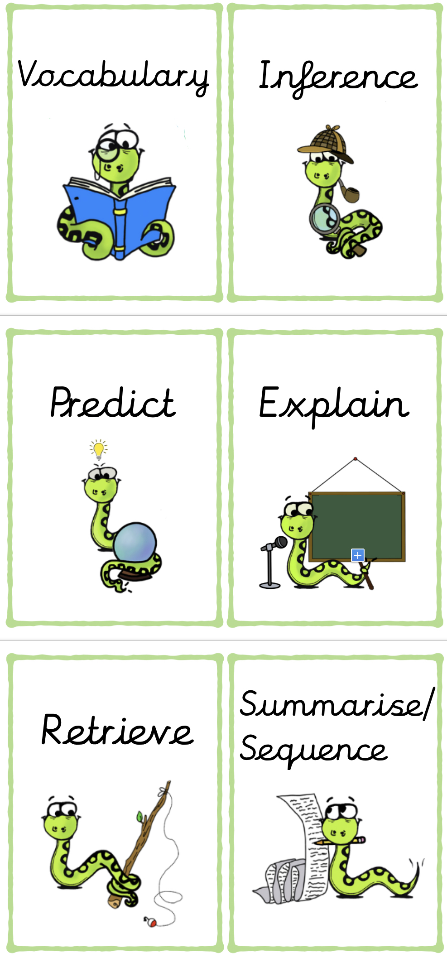
Appendix 7: VIPERS
Appendix 8: The Role of the Librarian

Role requirement of a Layton librarian:

To be a Layton Librarian you are required to:

*Love ALL books
*be able to identify genres of books and keep an order of this
*be able to promote books through posters and reviews to spread the word of enjoyable/new texts.
*read with other children, younger or older and to help them build their skills.
*be able to suggest book titles to others based upon their keen interests.
*take pride in our class and school library areas
*maintain the appearance and upkeep of our books and texts.
*suggest new books/texts for school to invest in and be able to explain your choices.
*assist with outdoor reading areas
*encourage others to read

Wear your librarian badge with pride!

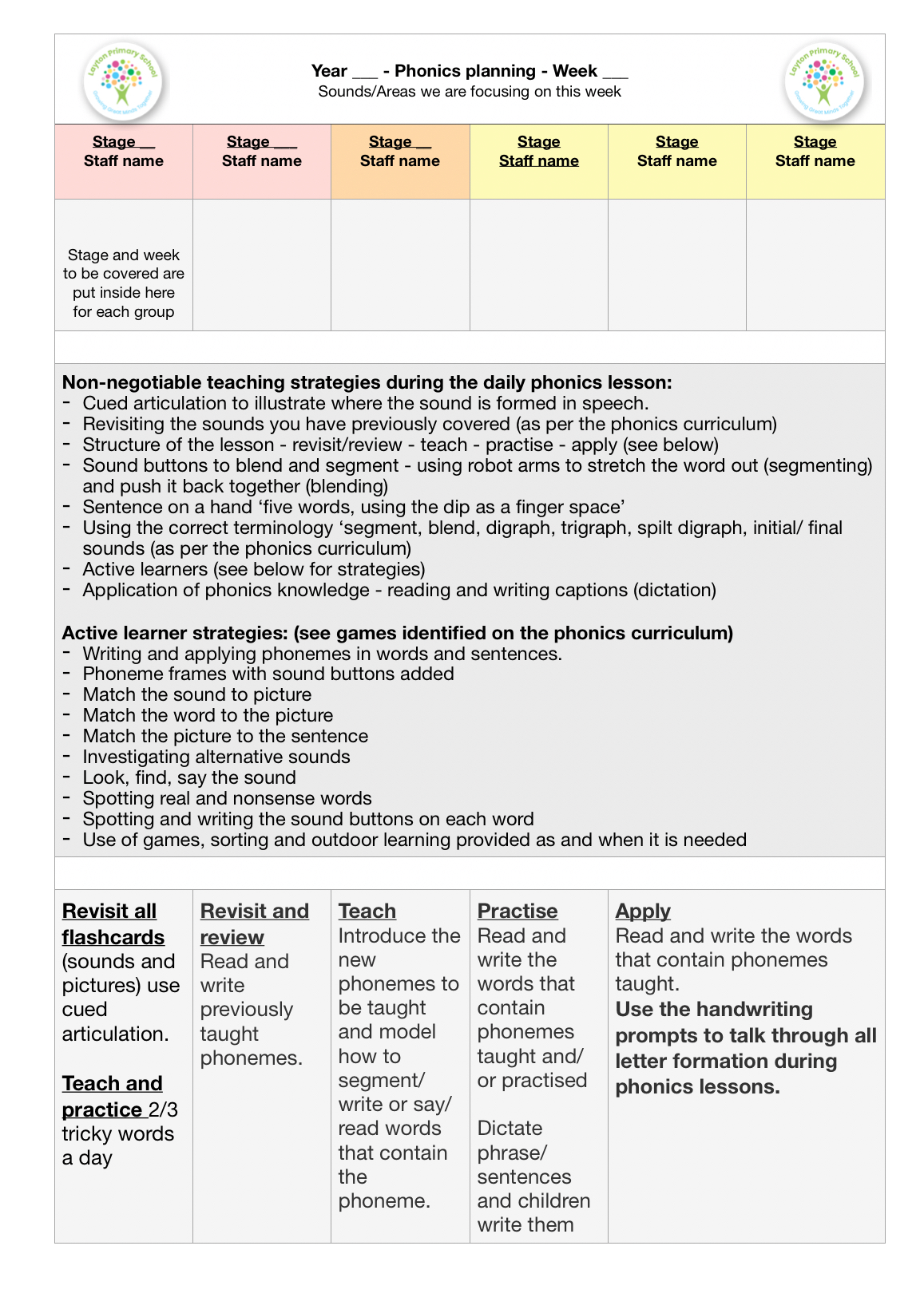
Appendix 9: Weekly Phonics Plan
Appendix 10: Precision Teaching Protocol
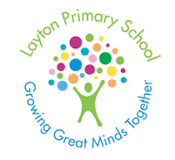
Precision Teaching - 1:1 - Phonics
Layton’s Letters and Sounds
Aims: Precision teaching in Phonics aims to boost individuals in: retrieval and repetition of Grapheme Phoneme Correspondences (GPCs); practise and consolidation of segmenting sounds to blend, use and application of knowledge of GPCs. This rote repetitive approach provides specific learning targets for each child that leads to fluency in the targeted skill.

At Layton, we believe that Precision Teaching and phonics complement each other well as mastering reading fluency facilitates capacity to think about and comprehend the text that is being read.
Phonics Precision Teaching Process
Step 1 - Identify a child for Precision Teaching
Using assessment for learning strategies (AfL) and/or summative assessment information, the child is identified for targeted support. Discuss the child with Class Teacher and/or Team Leader.
Step 2 - Identify the skill to be targeted
Using end of stage phonics assessments and afl, identify the specific SMART target that the child will work on e.g. To learn to retrieve 20 out of 26 sounds of Stage 3 of Layton’s Letters and Sounds.
Step 3 - Establish the baseline data to be measured from
Record the baseline as the starting point of the Precision Teaching sessions. E.g. Child A can retrieve 15 out of 26 sounds of stage 3 of Layton’s Letters and Sounds OR Child B can blend CVC words using SATPIN
Step 4 - Choose the GPCs to teach first
Depending on the child, choose 3 - 5 sounds to teach and/or practise retrieving or 3-5 words to practise segmenting to blend. These sounds can be taught using flashcards to retrieve and the teacher say the sound and the child writes the sound to encode.

Step 5 - Practise and consolidation of the GPCs taught
Develop fluency in the retrieval of the GPCs being targeted, or the word to be segmented and blended. This will usually be captured as ‘responses per minute’ and prompt sheets can be created using Widgit online.

Alongside this, children practise segmenting and blending using the targeted GPCs. Children need to be explicitly taught how to use and apply sound buttons and ‘spot the digraph’ to support the blending process.

Children will benefit from explicit teaching of using ‘robot arms’ to segment and blend. Children will benefit from repetition of this and increasing the speed of the blending of sounds. All teachers need to be mindful of any speech and language needs that may directly affect the pronunciation of sounds.
Step 6 - Record data daily on targeted skill
At the end of the PT session, record data and set new targets as and when required for the child’s target. If the target is achieved, set a new target based on a new skill to master. Ensure this information is shared with the CT.
Step 8 - Use and application of targeted skill
Where applicable, give children opportunity to use and apply new knowledge learned during the PT session.

Maximum time for PT session = 6 minutes (Foundation Stage)/
7 minutes (Year 1)/8 minutes (Year 2)

Review and share learning outcomes from the PT session, setting goals for the PT session tomorrow.

PT sessions x 1 per day

Suggested precision teaching sequence:
- Recap GPCs that the child already knows
- Introduce 3 new focus sounds
- Using a sound fan, show the 3 new sounds and 2 known sounds. Adult say the letter names, child name the digraph/trigraph. On occasions, introduce the next sound to be learned.
- Show children pictures of words that includes new sounds. Children orally segment the word represented by the picture. Adult say the word, children identify the digraph.
- Read word flash cards with new and familiar sounds.
- Assessment using probe sheet. This has to be completed every day and the sheet kept as a record of their progress.

This is not an exhaustive list, but can be mixed and matched on a daily basis to keep the children engaged.

In Foundation Stage, the focus will be on the children blending to read.

Suggested teaching sequence for oral blending Foundation Stage:

- Adult modelling oral blending - t - i -p - using the robot arms blend the sounds.
- “ Im thinking of a word b-e-d - What word is it?”
- Maximum practise of 4 words in a session, adult to model and child to copy.
- Record the score.

